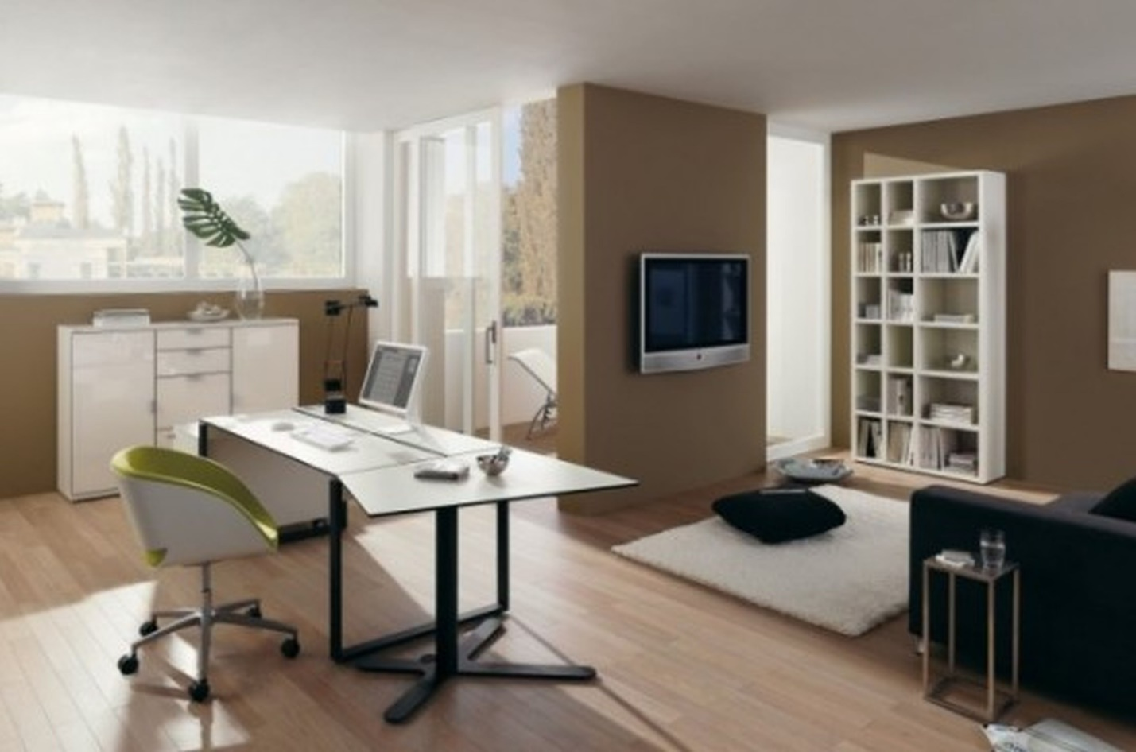
Task 1
Look through the words in Quizlet
Stationery
https://quizlet.com/304763299/flashcards

Task 2
Choose the most appropriate word:
1. Take those clothes out of the laundry basket and put them in the ___________ machine.
washing
washer
2. After you finish washing them, put them in the ________.
drying machine
dryer
3. Peter put the cutlery ( = knives, forks, etc.) in the wrong ________.
drawer
closet
4. Most people use an ironing ________ to iron their clothes.
border
board
5. Clothes ________ are used to hang clothes.
hangers
hangars
6. We need to get a new ________ for our table.
top-cloth
tablecloth
7. A chair that folds is called a ________ chair.
fold
folding
8. A ________ is a chair without arm or back rests.
stand
stool
9. Let's eat in the kitchen today. I don't feel like setting the ___________ table.
dining room
bedroom
10. We didn't have any more room in the basement, so we stored some of our things in the ________.
roof
attic

Task 3
Choose the most appropriate word:
1. Hey, it's your turn to ________ the bed.
make
do
sleep
2. Can you close the ________? The neighbors can see everything.
sheets
curtains
door
3. Can you get me another ________? It's going to be a cold night.
blanket
pillow
pillow case
4. A pillow ________ is something you put on your pillow so it won't get dirty.
sheet
frame
case
5. This room has no (electrical) ________.
jacks
circuit
outlets
6. Could you please turn off the light? The light ________ is by the door.
switch
switcher
turner
7. I need to wake up very early. Could you set the ________ for 6:00 AM?
clock
alarm
ring
8. Please hang your clothes in the ________ and don't leave them on the floor.
bed
closet
shelf
9. My girlfriend has cute pink ________ that she likes to wear around the house.
blouse
shirt
slippers
10. I haven't worn ________ since I was a kid.
ties
pyjamas
curtains

Task 4
Choose the most appropriate word:
1. You shouldn't take ________ pills. You might become addicted.
sleeping
sleep
night
2. I can't sleep in the same room as my grandfather because he ________ very loudly.
sleeps
snores
talks
3. I've been suffering from ________ for the past week. I just can't fall asleep.
insomnia
sleepless
fatigue
4. You're going to bed already? OK, pleasant ________!
thoughts
sleep
dreams
5. It was so hot that I was tossing and ________ all night.
teasing
crying
turning
6. A good night's ________ is important to refresh the body and mind.
sleep
sleeping
resting
7. I was so tired after working for 16 hours that I had no problems ________ asleep.
getting
falling
being
8. Hey, you seem a little ________ - would you like to take a nap?
awake
drowsy
angry
9. I'm a very ________ sleeper. Any little noise can wake me up.
easy
heavy
light
10. When you ________, you should close your mouth with your hand.
smile
yawn
sleep

Task 5
Complete each of the sentences below using the following words:
freezer, paper towels, knife, spoon, toaster, curtains, napkin, salad, refrigerator, oven
1. After you take the bread out of the …, put butter on it while it's still hot.
2. You have to pre-heat the … to 300 degrees.
3. Put the ice in the … .
4. Make sure that you close the … door. Otherwise, the food inside will go bad.
5. That … isn't very sharp.
6. You eat soup with a … .
7. After eating, my mother wiped her mouth with a … .
8. Close the … or the neighbors will see you.
9. Get the … . I spilled the spaghetti on the floor.
10. Add some tomatoes to the … .

Task 6
https://bogglesworldesl.com/quizgames/kitchenquiz.php

ANSWERS
Task 2
Choose the most appropriate word:
1. Take those clothes out of the laundry basket and put them in the ___________ machine.
washing
washer
2. After you finish washing them, put them in the ________.
drying machine
dryer
3. Peter put the cutlery ( = knives, forks, etc.) in the wrong ________.
drawer
closet
4. Most people use an ironing ________ to iron their clothes.
border
board
5. Clothes ________ are used to hang clothes.
hangers
hangars
6. We need to get a new ________ for our table.
top-cloth
tablecloth
7. A chair that folds is called a ________ chair.
fold
folding
8. A ________ is a chair without arm or back rests.
stand
stool
9. Let's eat in the kitchen today. I don't feel like setting the ___________ table.
dining room
bedroom
10. We didn't have any more room in the basement, so we stored some of our things in the ________.
roof
attic

Task 3
Choose the most appropriate word:
1. Hey, it's your turn to ________ the bed.
make
do
sleep
2. Can you close the ________? The neighbors can see everything.
sheets
curtains
door
3. Can you get me another ________? It's going to be a cold night.
blanket
pillow
pillow case
4. A pillow ________ is something you put on your pillow so it won't get dirty.
sheet
frame
case
5. This room has no (electrical) ________.
jacks
circuit
outlets
6. Could you please turn off the light? The light ________ is by the door.
switch
switcher
turner
7. I need to wake up very early. Could you set the ________ for 6:00 AM?
clock
alarm
ring
8. Please hang your clothes in the ________ and don't leave them on the floor.
bed
closet
shelf
9. My girlfriend has cute pink ________ that she likes to wear around the house.
blouse
shirt
slippers
10. I haven't worn ________ since I was a kid.
ties
pyjamas
curtains

Task 4
Choose the most appropriate word:
1. You shouldn't take ________ pills. You might become addicted.
sleeping
sleep
night
2. I can't sleep in the same room as my grandfather because he ________ very loudly.
sleeps
snores
talks
3. I've been suffering from ________ for the past week. I just can't fall asleep.
insomnia
sleepless
fatigue
4. You're going to bed already? OK, pleasant ________!
thoughts
sleep
dreams
5. It was so hot that I was tossing and ________ all night.
teasing
crying
turning
6. A good night's ________ is important to refresh the body and mind.
sleep
sleeping
resting
7. I was so tired after working for 16 hours that I had no problems ________ asleep.
getting
falling
being
8. Hey, you seem a little ________ - would you like to take a nap?
awake
drowsy
angry
9. I'm a very ________ sleeper. Any little noise can wake me up.
easy
heavy
light
10. When you ________, you should close your mouth with your hand.
smile
yawn
sleep

Task 5
Complete each of the sentences below using the following words:
freezer, paper towels, knife, spoon, toaster, curtains, napkin, salad, refrigerator, oven
1. After you take the bread out of the toaster, put butter on it while it's still hot.
2. You have to pre-heat the oven to 300 degrees.
3. Put the ice in the freezer.
4. Make sure that you close the refrigerator door. Otherwise, the food inside will go bad.
5. That knife isn't very sharp.
6. You eat soup with a spoon.
7. After eating, my mother wiped her mouth with a napkin.
8. Close the curtains or the neighbors will see you.
9. Get the paper towels. I spilled the spaghetti on the floor.
10. Add some tomatoes to the salad.

