Lesson 19-City-Grammar (part2)

Exercise 1
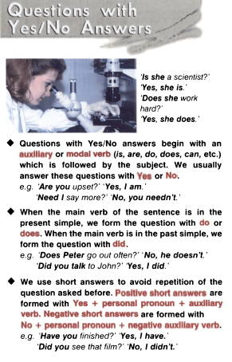

Exercise 2

Twenty Questions
In this yes/no question game, you have to guess the name of a famous person or character by asking the players 20 yes/no questions.
Write the name of a famous person or character on a piece of paper and give it to the player.
The other students take it in turns to ask yes/no questions to the player in order to find out his/her secret identity.
A 'yes' response from the player earns a questioner another chance to ask one more question.

Exercise 3
Write the questions using answers
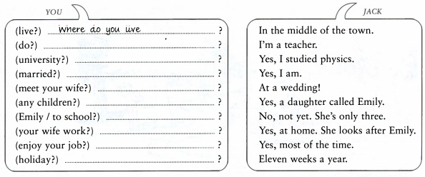
Exercise 4
An alternative question gives a choice of two or more answers in the question and includes or:
Would you like [choice 1]some ice cream or [choice 2]some cake?
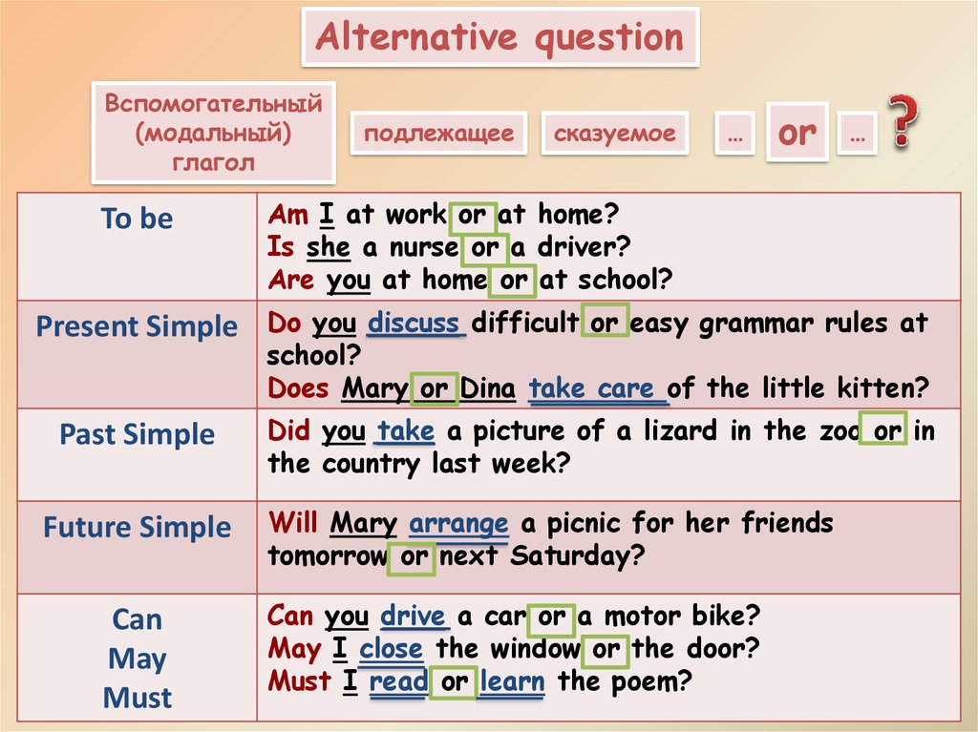

HOT POTATO
Put sentences in the right order
- Would you rather lose all of your money and valuables or all of the pictures you have ever taken?
- Would you rather be able to teleport anywhere or be able to read minds?
- Would you rather be able to talk with the animals or speak all foreign languages?
- Would you rather be a kid your whole life or an adult your whole life?
- Would you rather be rich and ugly or poor and good looking?
- Would you rather work really hard at an interesting job or slack off at a boring job?
- Would you rather go to jail for a year or live in your car for a year?
- Would you rather hang with a few friends or go to big party?

Exercise 5
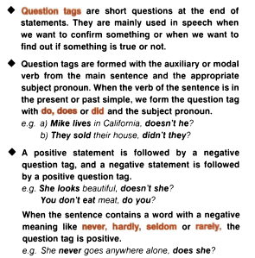  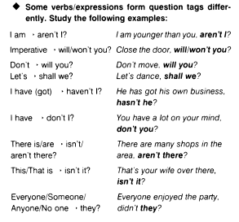 | Fill in the correct questions tags and short answers  - You’ve seen that film,….?  Yes, …  - They want to go skiing this year, …?  No,….They want to go on an adventure holiday  - He’ll probably be hungry when he comes in, …?  Yes, …..I’ll make him some sandwiches.  - She likes going to the cinema,…?  No, …..She prefers going to the theatre  - You’ve been to university, …?  Yes,…  - I’m a bit younger than Sally, …?  Yes,…  - They aren’t moving, …?  Yes, …  - You won’t forget to call me, ….?  No, …. Don’t worry  - You took some photographs at the ceremony, …?  Yes, …. They’re in this album  - He knows I’m planning a party for him,…?  No, …. He doesn’t suspect a thing  - They have bought a new car, …?  Yes, ….It’s a Volvo  - He works for his father, …?  Yes, …, His father owns a large company.  - I’m not late, ….?  No, ….You’re just on time  - They’ll be here in a minute, …?  Yes, …. We’d better tidy up  - You did the washing-up, …?  Yes, …. And I cleaned the kichen

Exercise 6
- A You’re new here, are you/aren’t you?
B Yes. I started work yesterday
A Ah. There are a lot of people working here, aren’t they/aren’t there?
- A You will remember to lock all the doors when you leave, will you/ won’t you?
B Of course. I’m not stupid, am I/ aren’t?
A No. But you forgot to lock the doors last week, didn’t you/did you?
B You’re not going to let me forget that, aren’t you/are you?
- A You haven’t seen Linda lately, have you/ haven’t you?
B I saw her today. I told you, did I/ didn’t I?
A Oh, yes! She didn’t mention the party, did she/ didn’t she?
B No, she didn’t. It’s tomorrow night, is it/ isn’t it?

