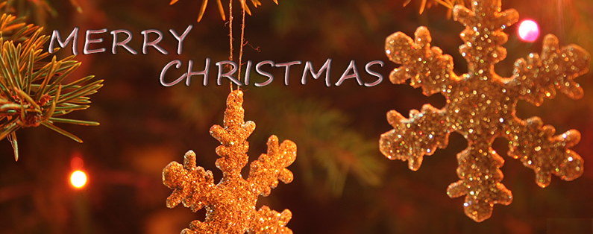
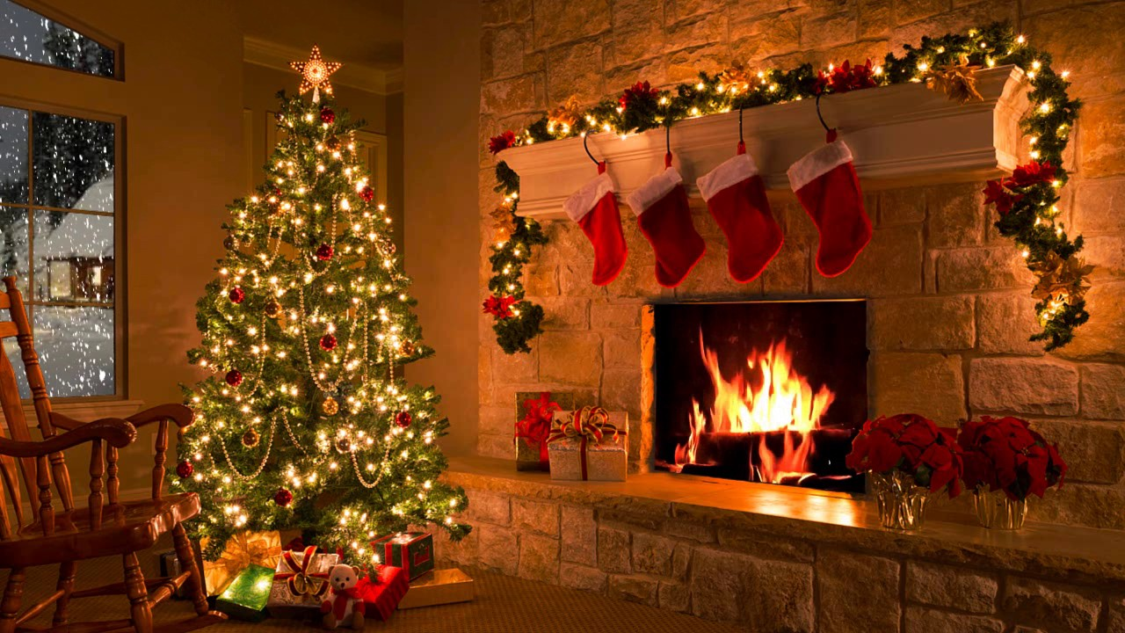

Quizlet:
https://quizlet.com/337696018/flashcards

I. Watch the video and answer the questions.
https://vimeo.com/82282346
- Does your family decorate your house over the Christmas/New year period? What sort of decorations do you put up? How many rooms do you decorate?
- Traditionally, when are decorations put up and taken down in your family/society?
- Do you save your decorations or buy new ones every year?
- What do you think of the practice of decorating the outside of the house during Christmas/New year?
- Do you have a Christmas tree? How is it decorated?
- Do you have a real or an artificial tree? Which do you think is best and why?
- Is the main street of your town decorated during the Christmas period? What is your opinion of the town's money being spent in this way?

II. Watch the video and answer the questions.
https://www.youtube.com/watch?v=zIEIvi2MuEk
- When do you do your Christmas shopping? Well in advance. A week in advance. The day before.
- Do you tell people what you want for Christmas or do you prefer it to be a surprise?
- Do you find choosing presents for people difficult? In what way?
- Do you give presents to everyone in your family, including cousins, aunts and uncles?
- How often do you receive presents that you really like, and how often do you have to pretend you are happy with a present?
- Do you enjoy carefully wrapping all your presents or do you feel it is waste of time?
- Are there certain presents that you know you'll always receive from certain people?
- On what day are gifts exchanged in your country? Do you know anything about traditions in other countries?
- When are gifts opened in your society?
- Which gives you the most pleasure - giving presents or receiving them?
- What presents did you get for Christmas - or - what do you hope to get?

III. Watch the video and answer the questions.
http://gamedata.britishcouncil.org/lep25_embed/MTA3MDE=/le
http://gamedata.britishcouncil.org/lep25_embed/MTA3MDA=/le
IV. Fill in the gaps.
