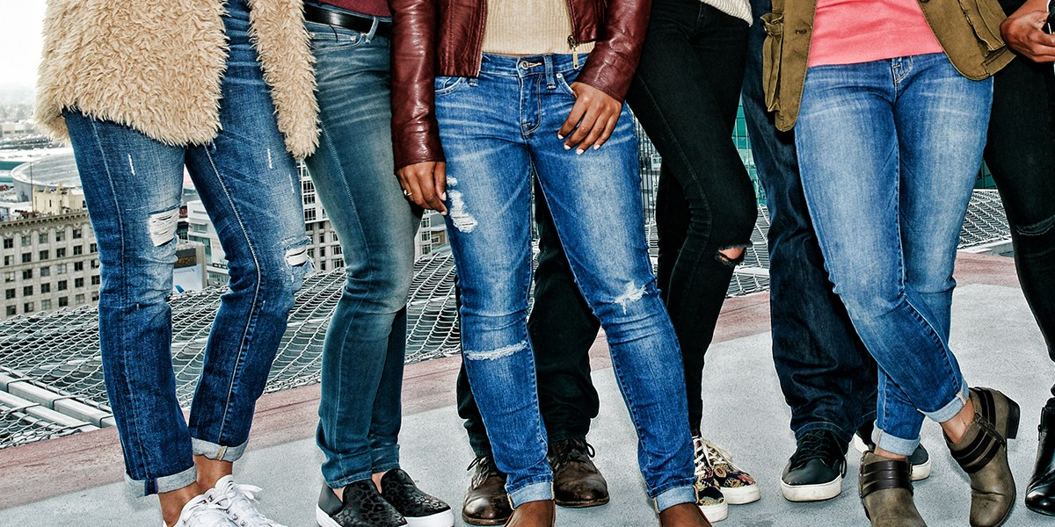

Ex 1. Look at the words and translate them into Russian
https://quizlet.com/311195786/english-lesson-27-reading-blue-jeans-flash-cards/

Ex. 2 Read the text about history of jeans

Levi Strauss, a young immigrant from Germany, arrived in San Francisco in 1850, California was in the middle of the Gold Rush. Thousands of men were coming to California to dig for gold. And Levi Strauss came to sell canvas to these gold miners. Canvas is a heavy fabric. So Levi Strauss thought the miners could use the canvas for tents. One day Strauss heard a miner complain that he couldn't find clothes strong enough for the work he was doing. Strauss got an idea. He quickly took some of his canvas for tents.
One day Strauss heard a miner complain that he couldn't find clothes strong enough for the work he was doing. Strauss got an idea. He quickly took some of his canvas and made it into pants. These pants were what the miners needed. In one day Strauss sold all the pants he had made.
Strauss wanted to improve his pants. He wanted to make them even better. He bought a fabric that was softer than canvas but just as strong. This fabric came from Nimes, a city in France, and was called serge de Nimes. The miners liked this fabric. They called it "denim" (from de Nimes) and bought even more pants from Strauss.
However, denim had no color. Because of this the denim pants did not look very interesting, and they got dirty easily. To solve these problems, Strauss dyed the denim blue.
Strauss continued to improve his jeans. Today, the company he started is known around the world. And jeans are considered not just practical but very fashionable as well.

Ex. 3 Choose the most suitable answer
1. Where was Levi Strauss from?
a. The USA
b. France
c. Germany
2. What was a profession of Levi Strauss?
a. A vendor
b. A needleman
c. A businessman
3. What problem did the miners have?
a. They didn’t have tents.
b. They didn’t have strong clothes.
c. They had dangerous illnesses.
4. Why did the miners call the fabric “denim”?
a. Because of the town
b. Because of its inventor
c. Because of the place, where they lived
5. What was a problem about the pants?
a. They were expensive.
b. They were not colorful.
c. They were uncomfortable.
6. What can we say about jeans today?
a. They are very popular.
b. They are not practical.
c. They need improvements.
7. What is the synonym for the word ‘dyed’ (paragraph 4)?
a. Exsiccated
b. Required
c. Stained
d. Requested

Ex 4 Match the picture with the word. (перемешать)
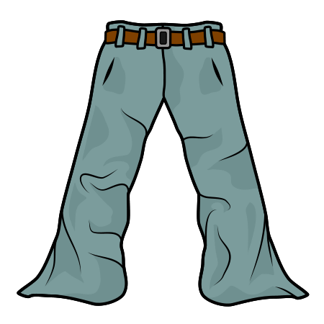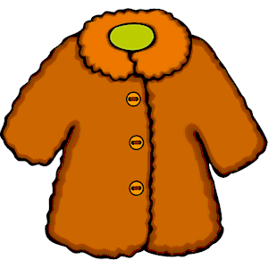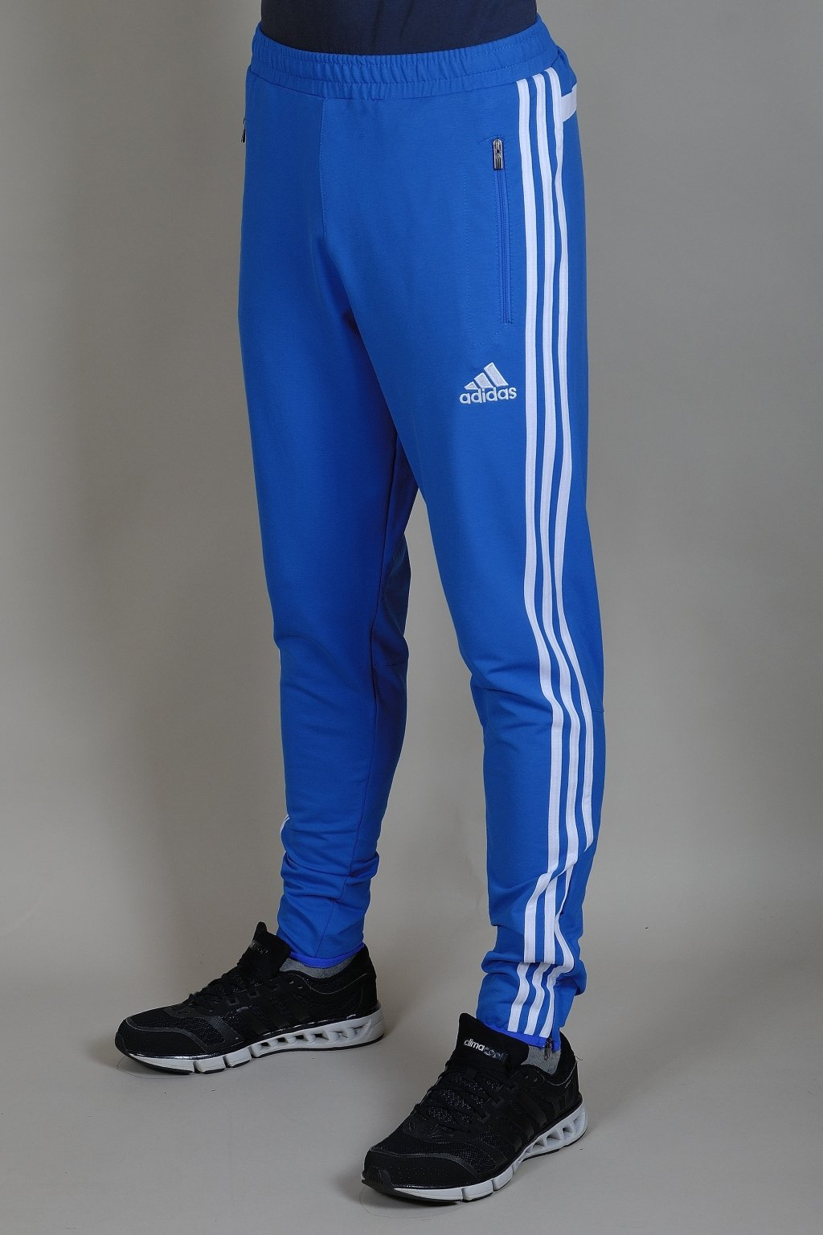

pants fur coat pajamas sweats

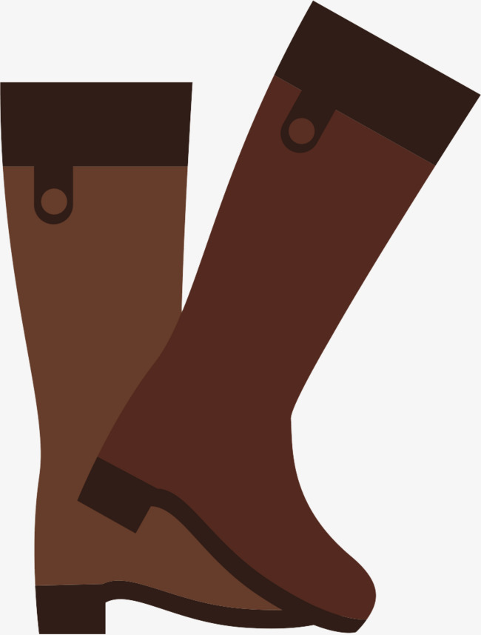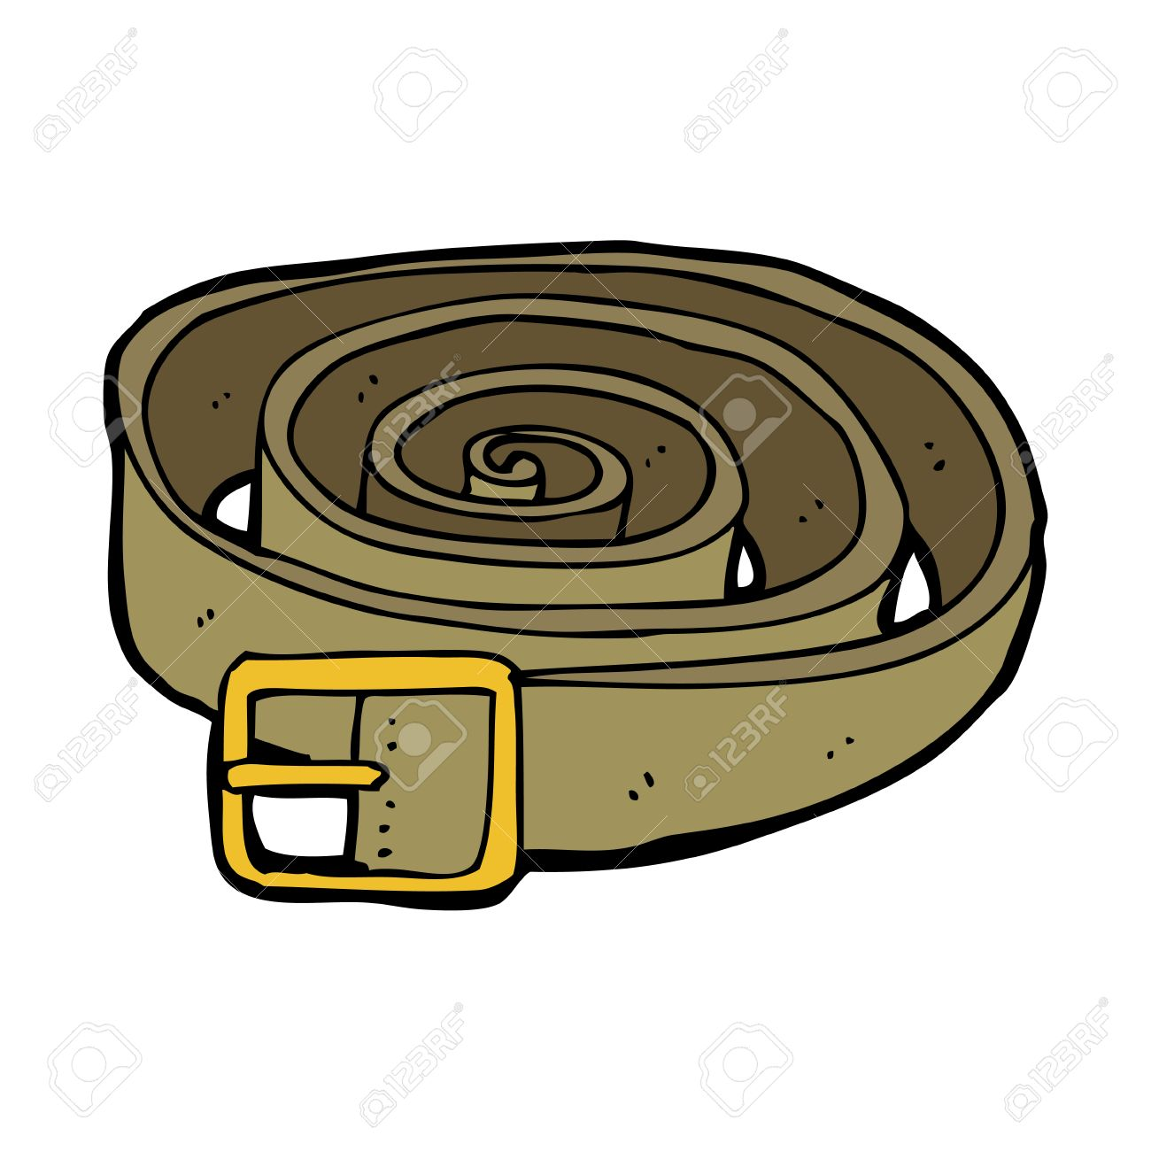

uniform boots belt

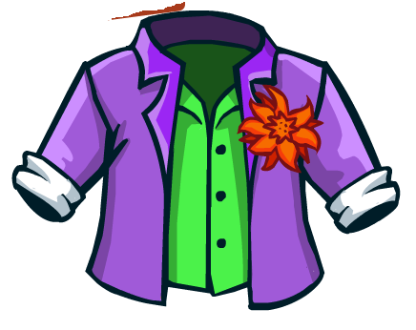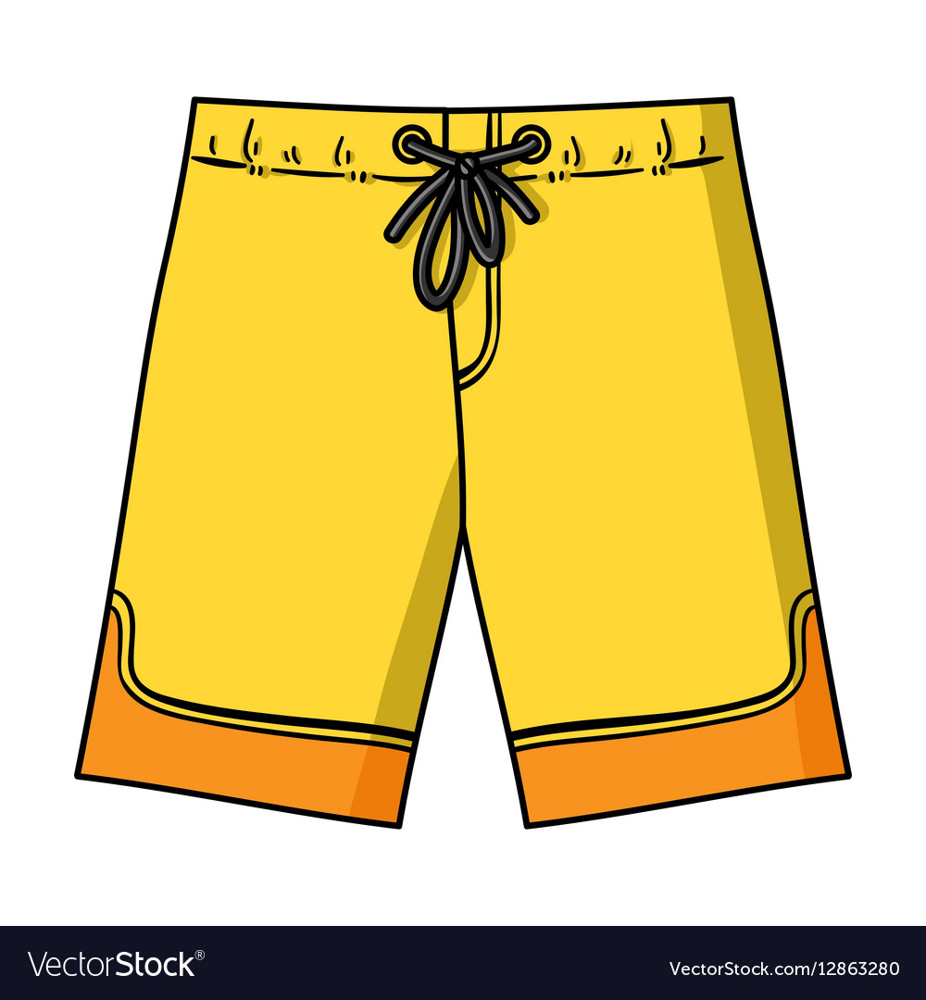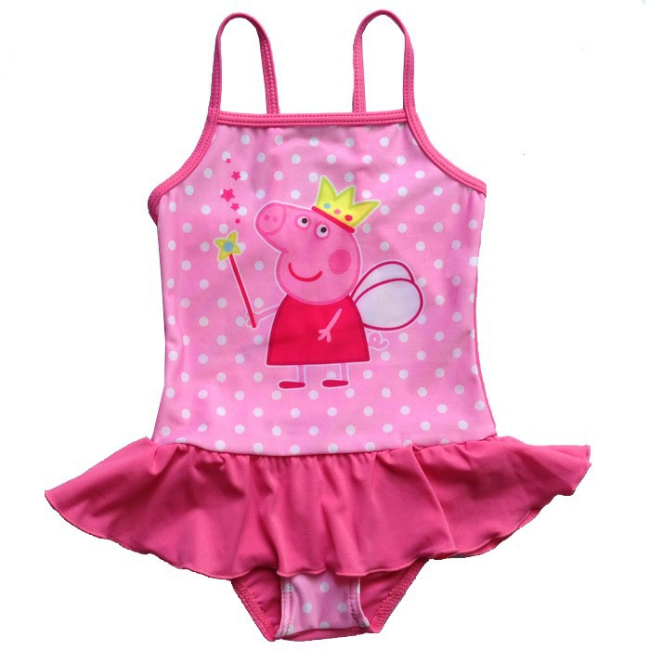
jacket swimming trunks swimsuit

Ex 5 Read and complete (перемешать)
Skirts Pants jeans fur coat shoes pajamas sweats uniform blouse
Scarf Boots belt shorts jacket swimming trunks swimsuit skirts

1 Pants and jeans usually come in pairs.
2 When it’s freezing, you’d better wear fur coat
3 I take off my shoes when I go inside.
4 I wear pajamas in bed.
5 In my free time I like wearing sweats
6 When I go to school I wear a uniform
7 A blouse and scarf are often made of silk.
8 Boots and belt are often made of leather.
9 In summer it’s best to wear shorts
10 Shirt and jacket have a collar.
11 In the swimming pool, men wear swimming trunks and women a swimsuit
12 It’s very unusual for boys to wear skirts

PDF

Ex 1. Look at the words and translate them into Russian
https://quizlet.com/311195786/english-lesson-27-reading-blue-jeans-flash-cards/

Ex. 2 Read the text about history of jeans

Levi Strauss, a young immigrant from Germany, arrived in San Francisco in 1850, California was in the middle of the Gold Rush. Thousands of men were coming to California to dig for gold. And Levi Strauss came to sell canvas to these gold miners. Canvas is a heavy fabric. So Levi Strauss thought the miners could use the canvas for tents. One day Strauss heard a miner complain that he couldn't find clothes strong enough for the work he was doing. Strauss got an idea. He quickly took some of his canvas for tents.
One day Strauss heard a miner complain that he couldn't find clothes strong enough for the work he was doing. Strauss got an idea. He quickly took some of his canvas and made it into pants. These pants were what the miners needed. In one day Strauss sold all the pants he had made.
Strauss wanted to improve his pants. He wanted to make them even better. He bought a fabric that was softer than canvas but just as strong. This fabric came from Nimes, a city in France, and was called serge de Nimes. The miners liked this fabric. They called it "denim" (from de Nimes) and bought even more pants from Strauss.
However, denim had no color. Because of this the denim pants did not look very interesting, and they got dirty easily. To solve these problems, Strauss dyed the denim blue.
Strauss continued to improve his jeans. Today, the company he started is known around the world. And jeans are considered not just practical but very fashionable as well.

Ex. 3 Choose the most suitable answer
1. Where was Levi Strauss from?
a. The USA
b. France
c. Germany
2. What was a profession of Levi Strauss?
a. A vendor
b. A needleman
c. A businessman
3. What problem did the miners have?
a. They didn’t have tents.
b. They didn’t have strong clothes.
c. They had dangerous illnesses.
4. Why did the miners call the fabric “denim”?
a. Because of the town
b. Because of its inventor
c. Because of the place, where they lived
5. What was a problem about the pants?
a. They were expensive.
b. They were not colorful.
c. They were uncomfortable.
6. What can we say about jeans today?
a. They are very popular.
b. They are not practical.
c. They need improvements.
7. What is the synonym for the word ‘dyed’ (paragraph 4)?
a. Exsiccated
b. Required
c. Stained
d. Requested

Ex 4 Match the picture with the word.

pants fur coat pajamas sweats

uniform boots belt

jacket swimming trunks swimsuit

Ex 5 Read and complete
1 … and … usually come in pairs.
2 When it’s freezing, you’d better wear …
3 I take off my … when I go inside.
4 I wear … in bed.
5 In my free time I like wearing …
6 When I go to school I wear a …
7 A … and … are often made of silk.
8 … and … are often made of leather.
9 In summer it’s best to wear …
10 Shirt and … have a collar.
11 In the swimming pool, men wear … and women a …
12 It’s very unusual for boys to wear …

