Lesson 35- At work-Grammar


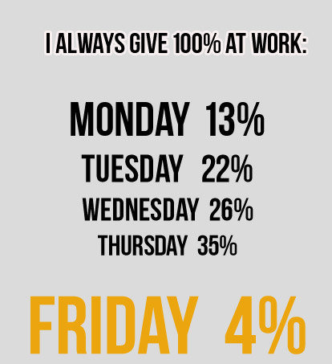

Exercise 1

Open the brackets using Present Perfect, Past Perfect, Past Continious, Past Simple
1. I just (to see) Jack.
2. She (to wash) the dishes from five till six.
3. Look! She (to draw) a very nice picture.
4. At this time yesterday I (to talk) to my friend.
5. The TV programme (to begin) before I (to come) home.
6. I (not to eat) ice-cream since summer.
7. I understood that she (not to read) my letter.
8. She (to do) the rooms when I (to come) home.
9. It's all right: she (to find) the way out of the situation.
10. He (to come) home late yesterday.
11. She is very glad: she (to finish) her composition at last.
12. He (to translate) the whole text by eleven o'clock.
1З. I never (to be) to Rome.
14. Last year we (to work) very much.
15. When I (to have) breakfast, I went to school.
16. I (not to see) you for ages! I am very glad to see you.
17. When you (to see) the «Swan Lake»?
18. My sister already (to graduate) from the institute.
19. He repaired the toy which his brother (to break) the day before.
20. I (to see) an interesting TV programme this week.
21. You ever (to be) to Trafalgar Square?
22. They (to cook) the whole day yesterday.

Exercise 2
Choose the appropriate tense either Present Perfect or Past Perfect
http://www.focus.olsztyn.pl/en-exercises-present-perfect-past-perfect.html

Exercise 3
Choose the right option
- I called my parents yesterday, but they (didn't return, hadn't returned, returned, were returning) from Haiti yet.
- Jessica was happy because she (has passed, had passed, passed, was passing) her exams very well
- Yesterday my friend (told, was telling, has told, had told) me an interestng story
- When we were friends, we always (played, were playing, have played, had played) games together
- He (spent, had spent, has spent, was spending) two weeks in Scotland two years ago
- The cat (drank, was drinking, has drunk, had drunk) all the milk which I (gave, had given, have given, was giving) it
- She (was doing, has done, had done, did) her flat the whole day on Saturday
- My sister (bought, has bought, had bought, was buying) a pair of nice model shoes this month
- At this time yesterday we (were talking, talked, have talked, had talked) about you
- I never (have been, had been, was) to the Bahamas

Exercise 4
Play the game
https://jeopardylabs.com/play/simple-past-present-perfect-and-past-perfect5

