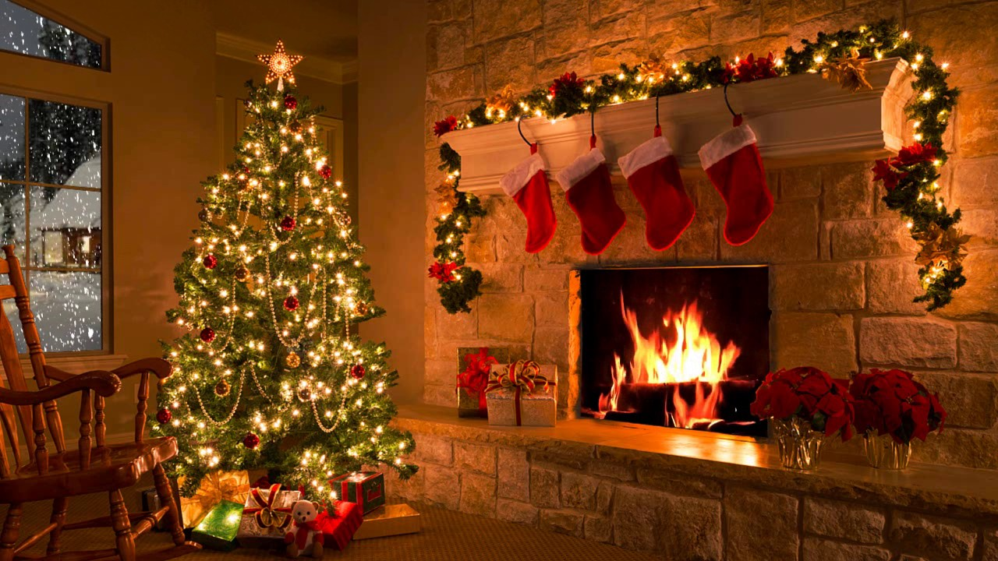

Ex. 1. Read the text:
Christmas
Hi! My name is Joana. I’m twelve years old and I live in Washington with my parents. We are very friendly.
December is my favourite month because I have holidays there. My sweetest holiday is also in December. It is Christmas. I love it. We decorate our house, the Christmas tree. I like to put balls and lights on the tree. My mother puts many candles on the tree. My father hangs a wreath on the door. Our house becomes very beautiful.
My elder sister always comes to us with her husband and her little daughter Mary. We have a holiday meal this day. We have a roasted goose, boiled potatoes, different salads, a pudding, soft drinks and juices for dessert.
We wish “Marry Christmas” to each other and give presents. We have a great time together.

Ex. 2. Choose True(T), False(F) or No information(NI) in the following statements:
1. The girl’s name is Helen.
2. She lives with her parents.
3. They live in Boston.
4. Her favourite month is December.
5. She also likes January.
6. Her favourite holiday is Christmas.
7. She likes to put candles on the table.
8. Her father makes a snowman in the yard.
9. Her mother puts the candles on the tree.
10. Her sister comes to them with her family.
11. They have a great time together.

Ex. 3. Answer the questions on the text:
1. How old is Joana?
2. Where does she live?
3. Who does she live with?
4. What is her favourite month?
5. What is her favourite holiday?
6. How does she decorate the tree?
7. What does her father do?
8. What does her mother do?
9. Who comes to them?
11. What do they have for Christmas?

Ex. 4. Complete the sentences:
1. Joana is …………..years old. 6. Joana puts balls and …………………on the tree.
2. She lives in ………………………… 7. Her mother puts …………………. on the tree.
3. She lives with her ………….. 8. Her elder sister comes to them..…………
4. They are very ………………….. 9. They have …………………….. for Christmas.
5. Her favourite month is … 10. They have a ………………………together.



Ex.5 Watch the video and complete the tasks
https://en.islcollective.com/video-lessons/christmas-love-mrs-claus

Ex.6 Quize

1. Santa Claus comes to us on his ____.

a) car
b) skies
c) sleigh

2. We always decorate the Christmas tree with ____.
a) candles and sweets
b) nuts and candles
c) lights and balls

3. Our parents put a lot of ____ under the Christmas tree.
a) books
b) balls
c) presents

4. We also put a beautiful _____ in our house.
a) birch tree
b) Christmas tree
c) apple tree

5. We always put our ____ on the fireplace.
a) socks
b) stockings
c) gloves

6. Rudolph is the name of Santa’s favourite ____.
a) bird
b) dog
c) reindeer

7. Children often build ___ in the street.

a) snowballs
b) snowflakes
c) a snowman

8. Our parents always hang ____ on the door.
a) a portrait
b) a wall paper
c) a wreath

Answer key

Ex. 2.
1. The girl’s name is Helen. F
2. She lives with her parents. T
3. They live in Boston. F
4. Her favourite month is December. T
5. She also likes January. NI
6. Her favourite holiday is Christmas. T
7. She Like to put candles on the table. F
8. Her father makes a snowman in the yard. NI
9. Her mother puts the candles on the tree. T
10. Her sister comes to them with her family. T
11. They have a great time together. T

Ex. 5.
1. Joana is 12 years old.
2. She lives in Washington.
3. She lives with her parents.
4. They are very friendly.
5. Her favourite month is …
6. Joana puts balls and lights on the tree.
7. Her mother puts many candles on the tree.
8. Her elder sister comes to them with her husband and her little daughter..
9. They have a roasted goose, boiled potatoes, different salads, a pudding, soft drinks and juices for Christmas.
10. They have a great time together.

Ex.6

1. Santa Claus comes to us on his ____.

a) car
b) skies
c) sleigh

2. We always decorate the Christmas tree with ____.
a) candles and sweets
b) nuts and candles
c) lights and balls

3. Our parents put a lot of ____ under the Christmas tree.
a) books
b) balls
c) presents

4. We also put a beautiful _____ in our house.
a) birch tree
b) Christmas tree
c) apple tree

5. We always put our ____ on the fireplace.
a) socks
b) stockings
c) gloves

6. Rudolph is the name of Santa’s favourite ____.
a) bird
b) dog
c) reindeer

7. Children often build ___ in the street.

a) snowballs
b) snowflakes
c) a snowman

8. Our parents always hang ____ on the door.
a) a portrait
b) a wall paper
c) a wreath

