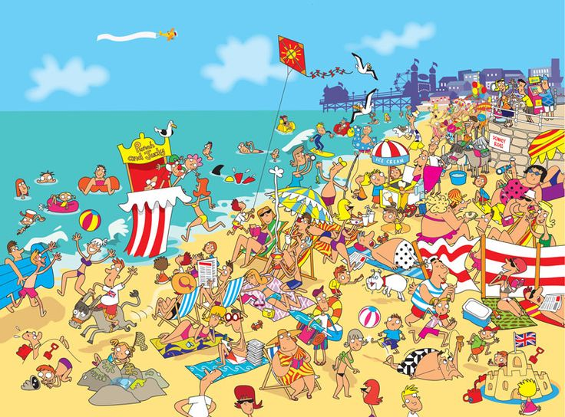

Task 1
Describe this picture. Compare it with the previous one. Are they different?
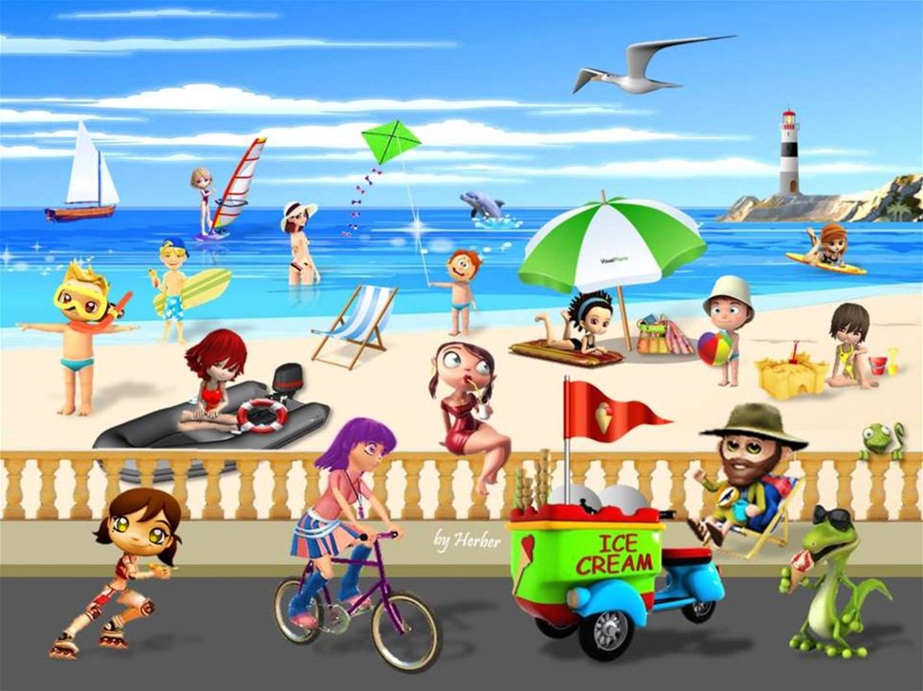
Task 2
Answer the following questions about summer:
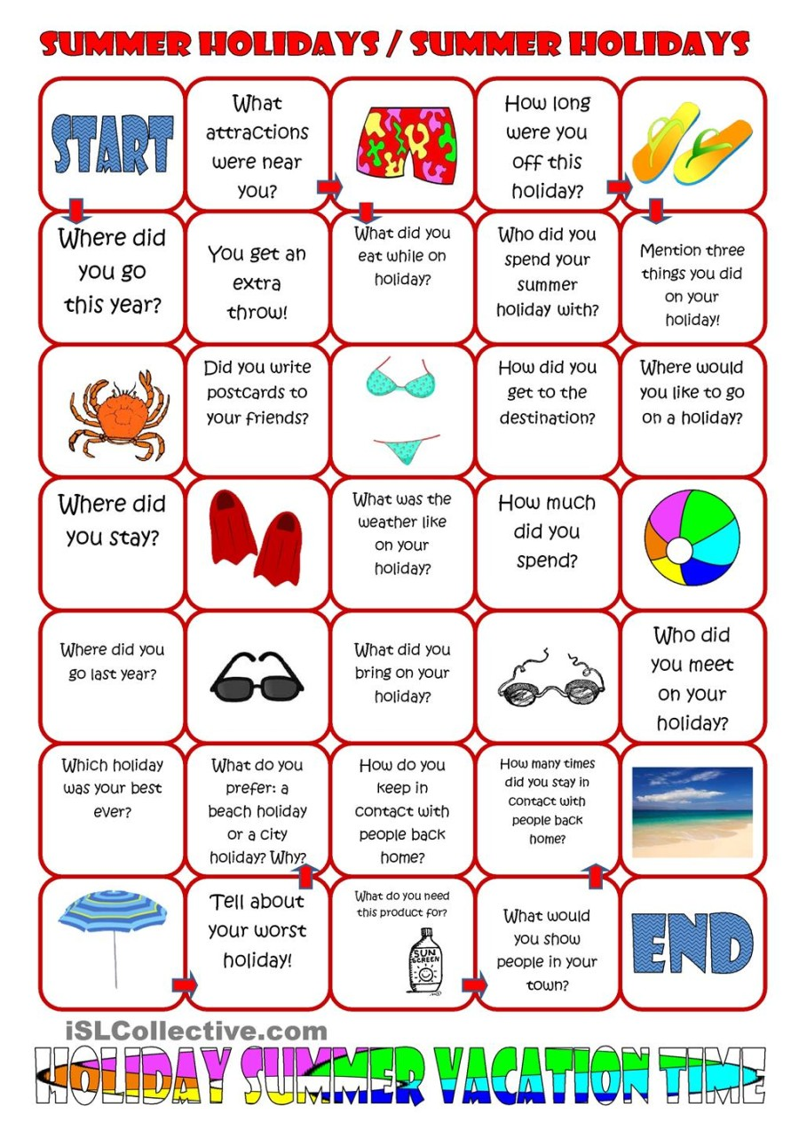
Task 3
Tell about your summer holidays using the following words:
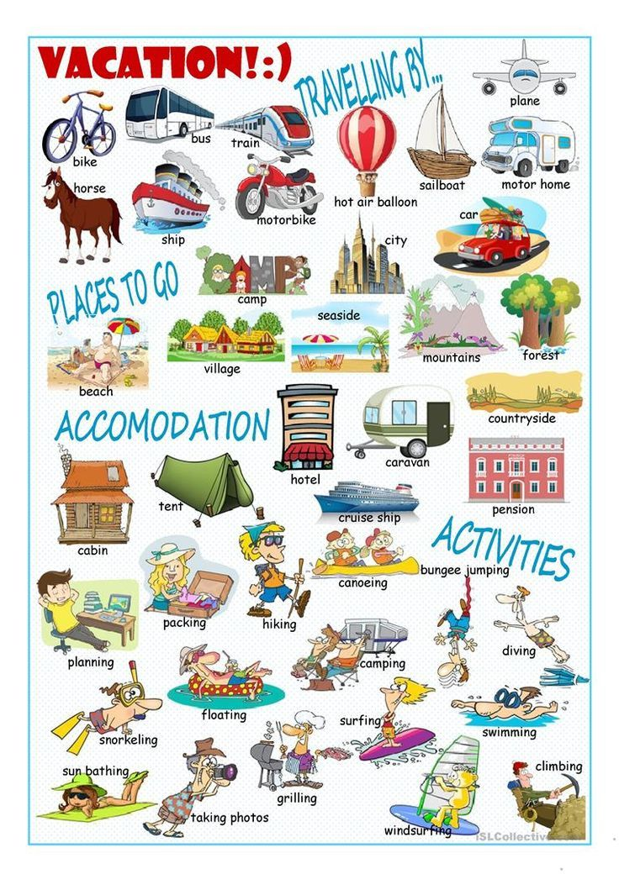
Task 4
Watch the video about summer:
https://www.youtube.com/watch?v=enitMtGnw3Y

Task 5
Choose if these sentences are true or false:
1.It was a good day to pick strawberries and to go to the beach.
2.People were not wearing sun hats because it was so warm in strawberries farm.
3.There is a 50 km away large city from the beach.
4.Only the daughter entered the water.
5.They made a strawberry dessert with cake and ice cream.

Task 6
Do these quizzes about summer:
https://bogglesworldesl.com/quizgames/summerquizgame.php
https://bogglesworldesl.com/quizgames/summerquiz.php

ANSWERS
Task 5
1.It was a good day to pick strawberries and to go to the beach. True
2.People were not wearing sun hats because it was so warm in strawberries farm. False
3.There is a 50 km away large city from the beach. True
4.Only the daughter entered the water. False
5.They made a strawberry dessert with cake and ice cream. True

