016_intermediate_grammar
Past Perfect, Past Perfect Continuous

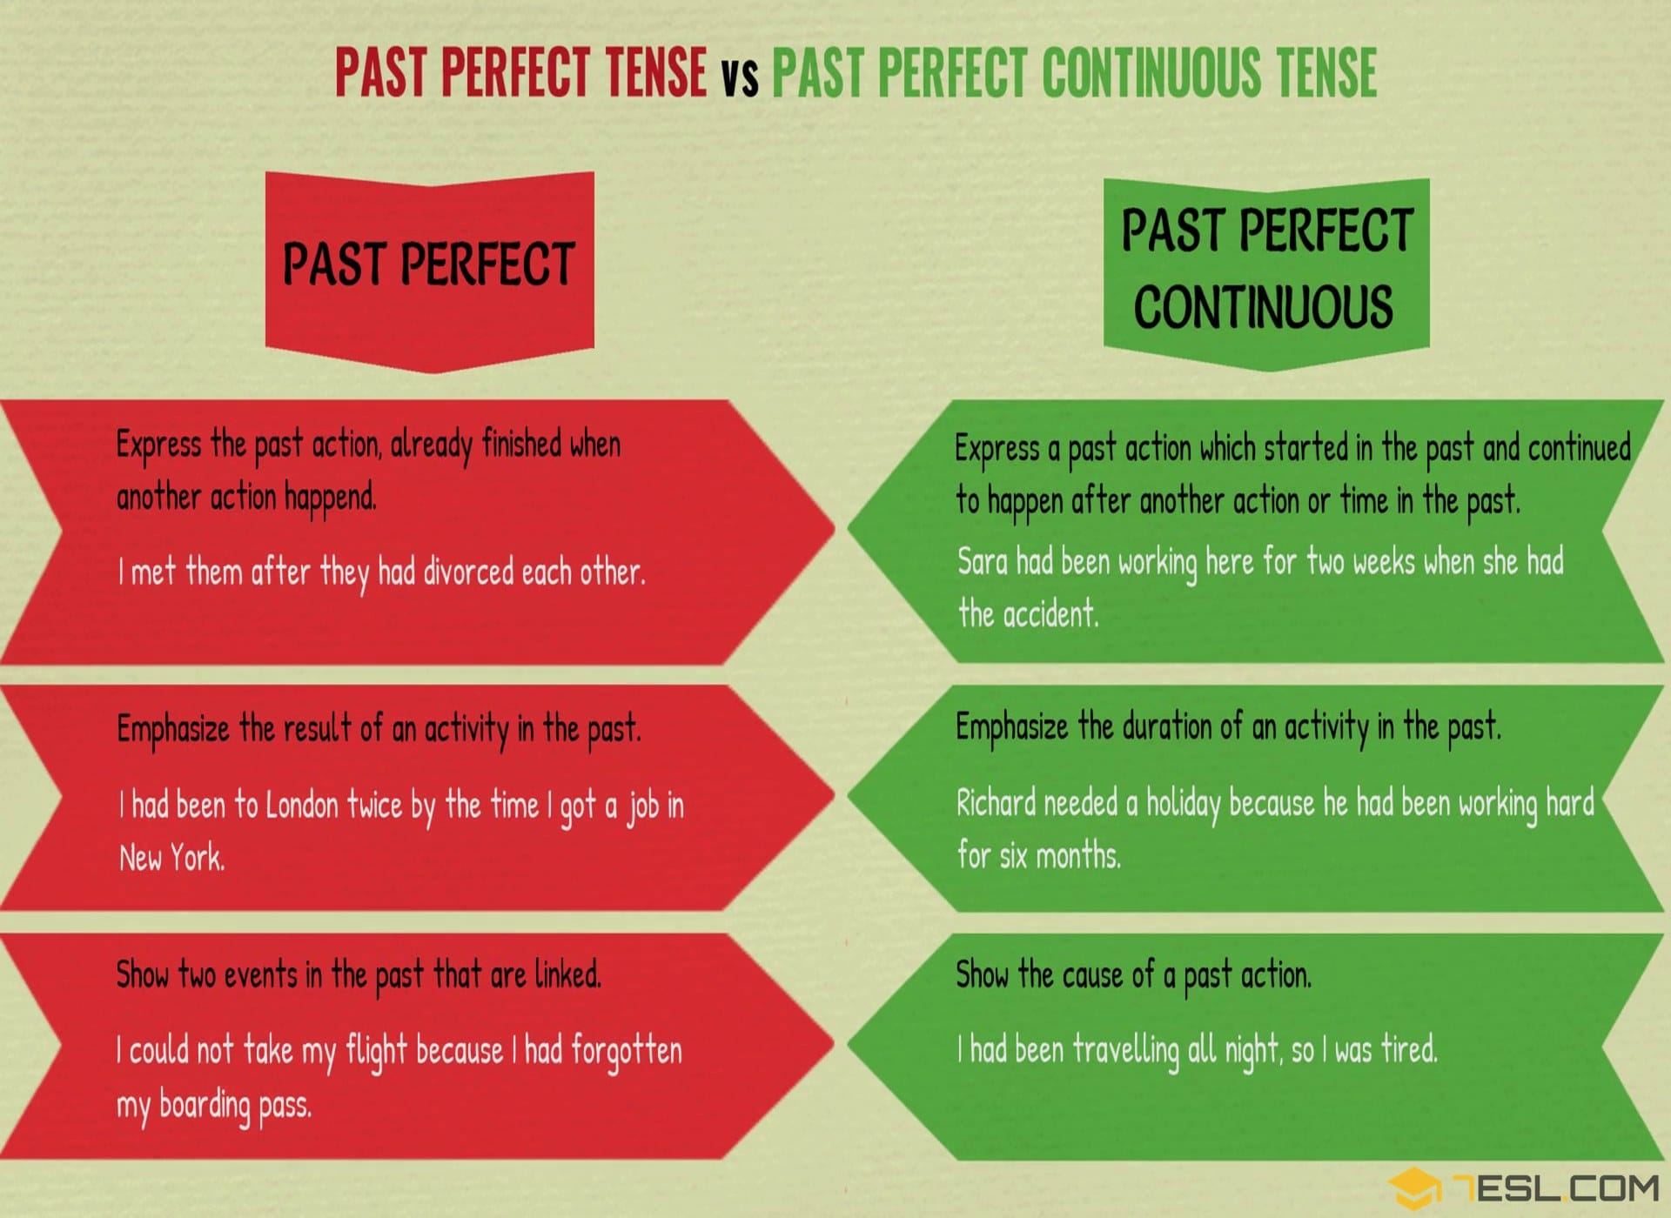

Exercise 1
It was Marie’s birthday party yesterday. What had she done before the party? Look at the pictures and give the answers.
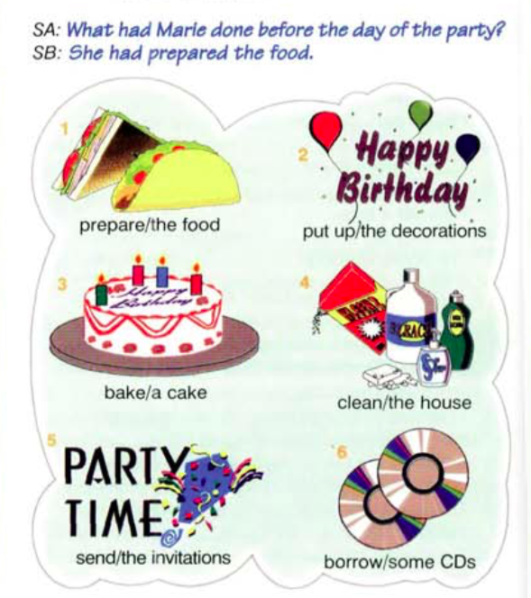

Exercise 2
Match up two parts of the sentences.
- By the time he reached the airport
- Mary was angry because
- The bank robbers had escaped
- We went to the theater
- The actress gave an interview

- her husband had forgotten about her birthday.
- after we had bought the tickets
- the plane had already taken off
- after she had won the prize
- before the police arrived

Exercise 3
Open up the brackets using either Past Perfect or Past Perfect Continuous

Yesterday was a bad day for Andrew. He 1) .... (not/sleep) well because there was a terrible storm in the night. 2).... (have) a shower, he made breakfast. After he 3…. (eat), he got into his car and drove to work. He 4) …. (only/drive) for five minutes when he remembered that he 5) …. (leave) his briefcase at home. He turned the car around and went home again. Then, he realized that he 6) .............(lock) himself out. The keys were still inside the house! Andrew was already late for work, so he decided to leave the briefcase and go to work. When he arrived, his secretary told him that his boss 7) …. (try) to call him home. Andrew went to find his boss. When he asked his boss why he 8)…… (call), he told him that it hadn't been necessary for him to come to work that day after all! Poor Andrew drove all the way home again.

Exercise 4
Match up the pictures with the sentences
- She was wet. She had been walking in the rain.

- They were happy. They had been playing for hours.

- He was irritated. He had been waiting for a bus for an hour.
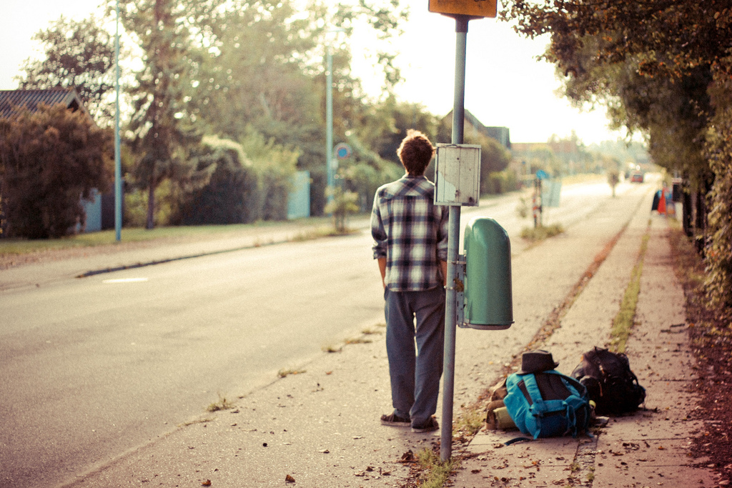
- He was tanned. He had been tanning for hours.

- They were happy. They had been talking the entire morning.


- They were tired. They had been writing the test for two hours.

- Linda was exhausted. She had been shopping the entire day.

- Pete was sweaty. He had been running for an hour.


Exercise 5
Choose the right answer
had dusted; had been waiting had been sitting; had put; had just started; had just arrived; had only been playing; had been cleaning; had been trying;

- A: Did you do anything last night?
B: I went to the gym and I _____ home when Michael called me. He said _____to call me for ten minutes before I finally answered the phone.

2. A: Did you catch any fish on your fishing trip today?
B: Yes, I _____ in the boat for two hours when I caught a huge fish.

3. A: Did you enjoy the open-air concert yesterday?
B: The music was good, but the weather was terrible. The concert _____when it suddenly began to rain. The musicians _____ for ten minutes.
A: What a shame!

4. A: Was the house tidy when you got home?
B: Yes, the children _____ the furniture and they _____ away all of their toys.

- A: Why were you so upset this morning?
B: Well, I _____ for hours when the children came in dirty shoes.

6 A: Why are you so late for work this morning?
B: I am sorry. I _____ for train for over an hour before it eventually arrived.

Exercise 6
Choose the right answer
- I … four cups of coffee today.
  - have drunk
  - drank
  - have drank
- At last the bus came. We … for 20 minutes.
  - had waited
  - had been waiting
  - waited
- I felt very tired when I got home, so I … straight to bed.
  - have gone
  - had gone
  - went
- Sarah went to Sue’s house, but she wasn’t there. She … .
  - went out
  - had gone out
  - has gone out
- Jim is on holiday. He … to Italy.
  - went
  - had gone
  - has gone
- We were extremely tired at the end of the journey. We … for more than 24 hour.
  - had been traveling
  - have travelled
  - travelled
- When I got home, Tom was sitting in front of the TV. He had just turned it off. He … a film.
  - had been watching
  - was watching
  - watched
- Rob … very hard this term.
  - has studied
  - is studying
  - studied
- Jim was on his hands and knees on the floor. He … for his contact lens.
  - had been looking
  - looked
  - was looking
- Linda is a teacher. She … for ten years.
  - works
  - has been working
  - is working
- My hands are very dirty. I … the car.
  - have repaired
  - was repairing
  - have been repairing
- Sarah is very tired. She … very hard recently.
  - worked
  - was working
  - has been working
- I’m Spanish. I started classes in December. I … since December.
  - learn
  - have been learning
  - am learning
- I didn’t know who she was. I … her before.
  - never saw
  - had never seen
  - have never seen
- The house was dirty. They … it for weeks.
  - have been cleaning
  - had cleaned
  - hadn’t cleaned
- Kate … home when I phoned.
  - just got
  - has just got
  - had just got
- Bill is phoning his girlfriend again. That’s the second time he … her this evening.
  - phones
  - had phoned
  - has phoned
- Joe … too much recently. He should eat less.
  - ate
  - has been eating
  - was eating
- We … for half an hour when it … to rain.
  - had been playing / started
  - played / started
  - had been playing / had started
- Susan really loves that film. She … it eight times
  - had seen
  - saw
  - has seen
HOME MORE TESTS

