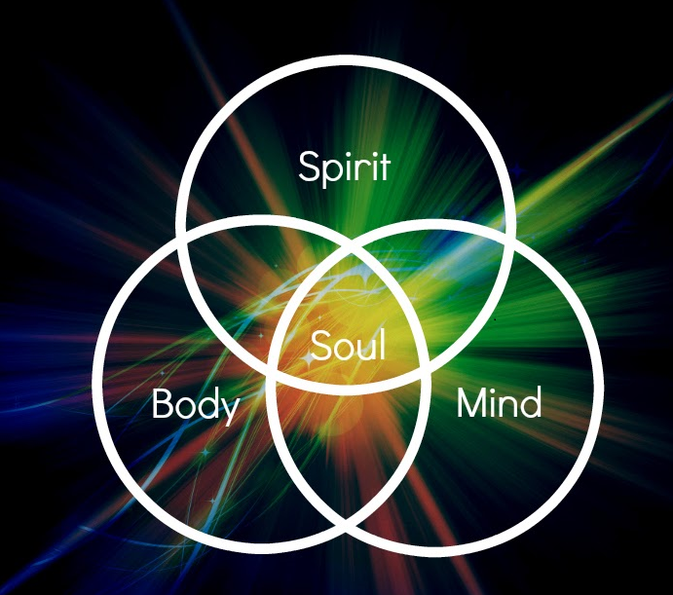


I. Quizlet.
https://quizlet.com/36505081/flashcards

II. Choose the correct word in each sentence.
a) The trousers are the right length, but the stomach / waist is too small.

b) I like this watch, but the strap is too small for my palm / wrist.

c) The hand has four fingers and a thumb/toe.

d) When Robert is nervous he tends to bite his nails/joints.

e) This bag has a strap and I can carry it on my neck / shoulder.

f) Gina twisted her ankle / elbow and she can’t walk very easily.

g) Paul dropped the stone on his foot and broke two toes / fingers.

h) When you’re worried lines appear on your eyebrows / forehead.

II. Complete each expression in italics with one of the parts of the body from the box.

arms eye face foot hair hand head heart leg tongue
a. The word is on the tip of my , but I just can’t remember it.
b. Crossing the mountains on my own was a -raising adventure.
c. I know this is hard to believe, but you must the truth.
d. It is now over thirty years since man first set on the moon.
e. After his long trip Tom's parents welcomed him with open .
f. Peter knows the songs by and doesn't need to look at a book.
g. Try to stay calm, and don’t lose your , and everything will be fine.
h. Have I really won the prize, or are you only pulling my .
i. Lisa needs some help with her suitcase, Could you give her a .
j. I waved at Ann, hoping to catch her , but she didn’t see me.
III. Name the parts of the body.
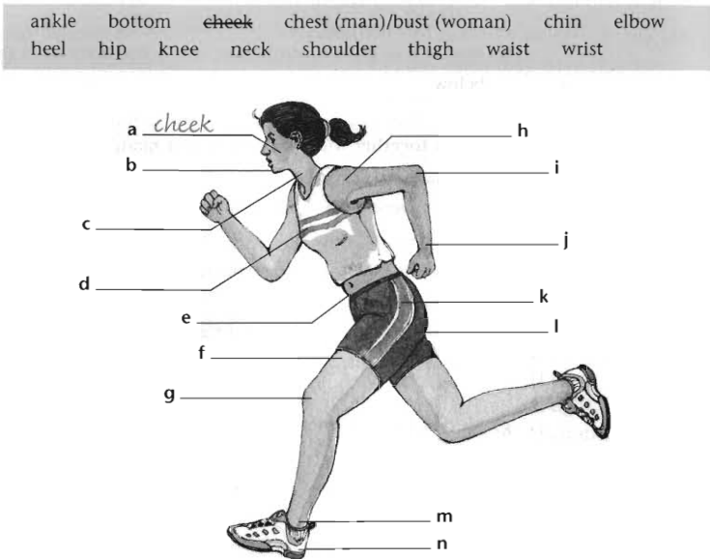

IV. Choose the correct word for the definition.
http://gamedata.britishcouncil.org/lep25_embed/MjE3Njg=/le

V. Put the chunks in order to make sentences.
http://gamedata.britishcouncil.org/lep25_embed/MjE3NzY=/le

VI.

Answers:
II. Choose the correct word in each sentence.
a) The trousers are the right length, but the stomach / waist is too small.

b) I like this watch, but the strap is too small for my palm / wrist.

c) The hand has four fingers and a thumb/toe.

d) When Robert is nervous he tends to bite his nails/joints.

e) This bag has a strap and I can carry it on my neck / shoulder.

f) Gina twisted her ankle / elbow and she can’t walk very easily.

g) Paul dropped the stone on his foot and broke two toes / fingers.

h) When you’re worried lines appear on your eyebrows / forehead.

II. Complete each expression in italics with one of the parts of the body from the box.

arms eye face foot hair hand head heart leg tongue
a. The word is on the tip of my , but I just can’t remember it.
b. Crossing the mountains on my own was a -raising adventure.
c. I know this is hard to believe, but you must the truth.
d. It is now over thirty years since man first set on the moon.
e. After his long trip Tom's parents welcomed him with open .
f. Peter knows the songs by and doesn't need to look at a book.
g. Try to stay calm, and don’t lose your , and everything will be fine.
h. Have I really won the prize, or are you only pulling my .
i. Lisa needs some help with her suitcase, Could you give her a .
j. I waved at Ann, hoping to catch her , but she didn’t see me.
a. tongue b. hair c. face d. foot e. arms f. heart g. head h. leg i. hand j. eye
III. Name the parts of the body.

a. cheek b. chin c. neck d. bust e. waist f. thigh g. knee h. shoulder i. elbow j. wrist k. hip l. bottom m. ankle n. foot

