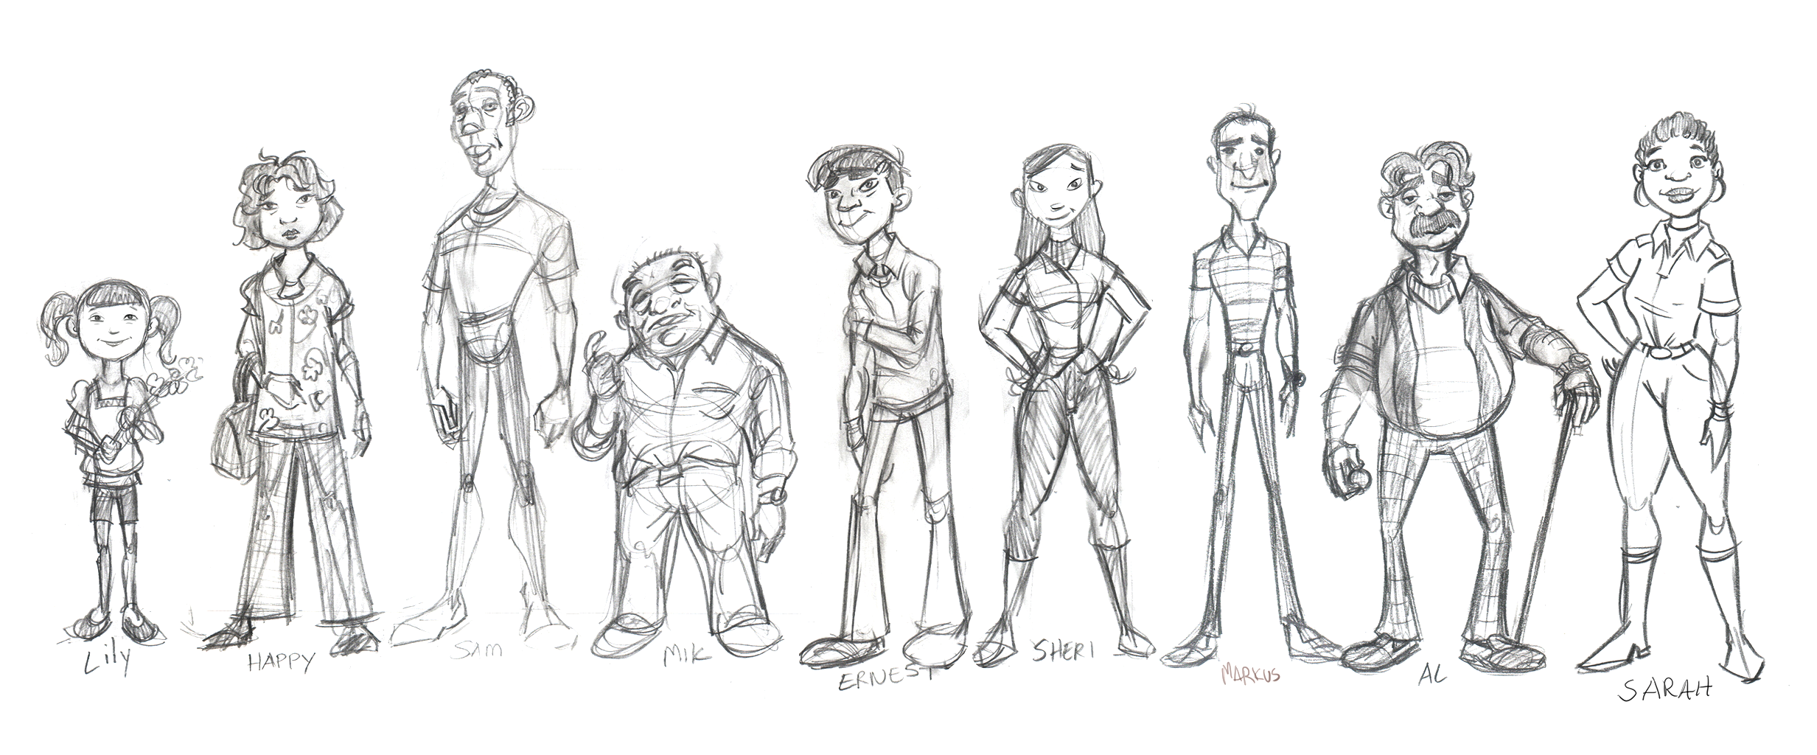

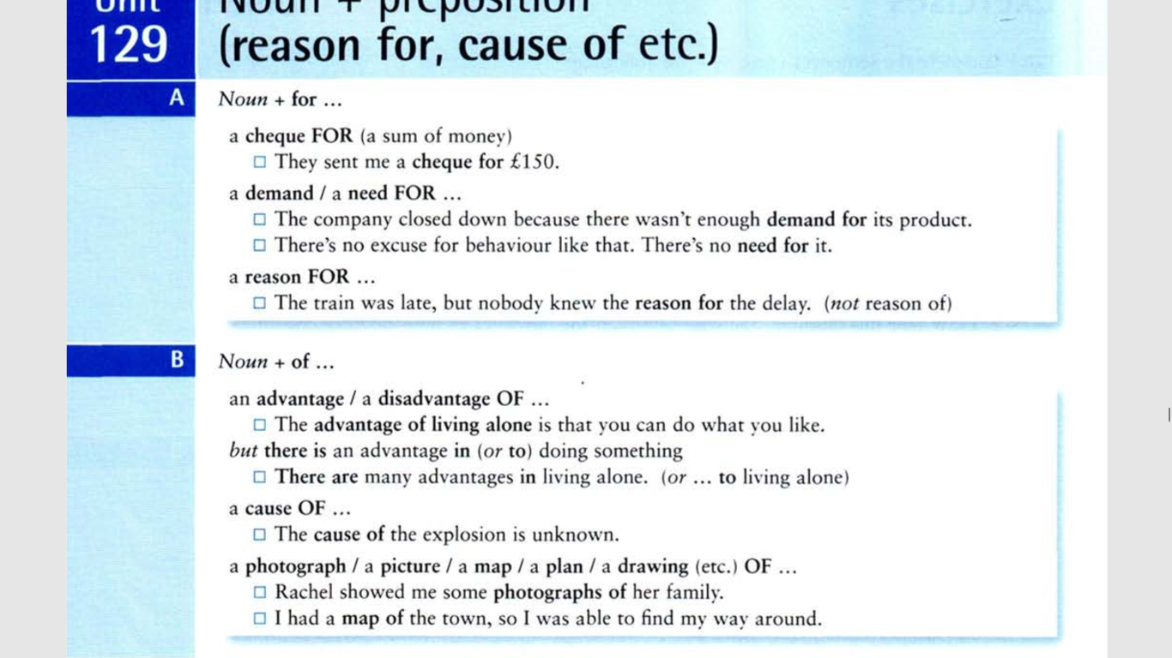
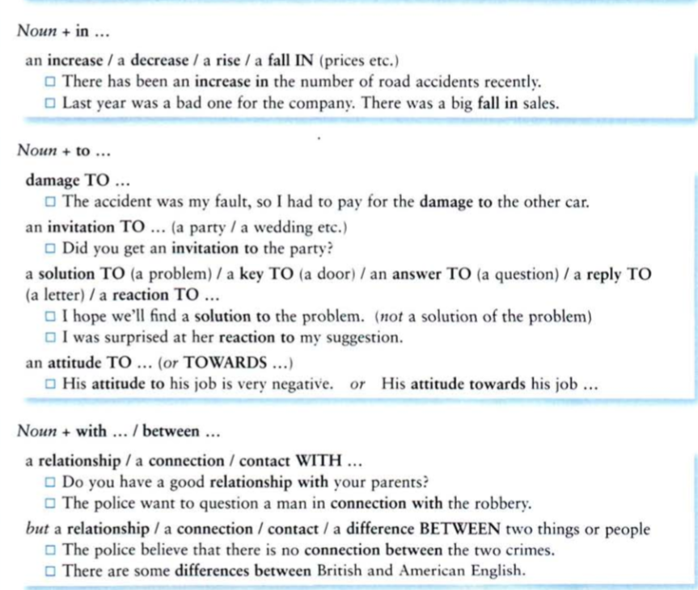

Task 1
Choose the correct variant:
1. He gave her a check _____ a lot of money.
for
in
of
to
with
2. The reason _____ this meeting is to discuss the merger.
for
in
of
to
with
3. The decrease _____ profits is due to the bad market.
for
in
of
to
with
4. There is a real demand ______ new products.
for
in
of
to
with
5. We have seen a fall ______ prices recently.
for
in
of
to
with
6. The cause ______ his problems is his family.
for
in
of
to
with
7. Did you do any damage ______ the house?
for
in
of
to
with
8. I think your attitude _____ your sister is very bad indeed.
for
in
of
to
towards
9. The difference _____ the two is very slight.
for
in
between
to
with
10. He took a photograph ______ his girlfriend.
for
in
of
to
with
11. Do you have a good relationship ______ most of your relatives?
for
in
of
to
with
12. She wasn't aware ______ his reaction to the problem.
for
in
of
to
with
13. Did you send Alice an invitation ______ the party?
for
in
of
to
with
14. The connection _______ the two victims was minimal.
for
in
of
to
between
15. The advantage ______ having free time is that you can do anything you want with it.
for
in
of
to
with
16. He made a mistake _______ thinking that Alice was someone he could easily fool.
for
in
of
to
with

Task 2
Choose the correct variant:
1. We had little hope … success; nonetheless, we decided to perform the operation.
for
about
of
2. The cash-for-vote scandal did a lot of harm … his reputation as a conscientious politician.
for
to
at
3. We have to find a substitute … it.
to
for
at
4. We should deem it as an attack … our right to privacy.
with
on
at
5. In many cities the cost … living is pretty high.
to
for
of
6. We would like to see a big increase … productivity.
with
in
on
7. I have no interest … politics.
for
at
in
8. I have no faith … her capabilities.
at
in
on
9. I have heard that the government is planning to raise the tax … automobiles.
on
for
with
10. I admire their way … doing things.
for
of
with

Task 3
Choose the correct variant:
1. I really need a BREAK ___ drinking alcohol!
of
from
at
2. Her skin has a really bad REACTION __ the sun.
with
to
at
3. There has been a huge RISE ___ food prices recently.
at
with
in
4. I think I have an ADDICTION ___ chocolate.
with
to
about
5. I have huge RESPECT ___ my teachers at school, now I know how hard it can be!
with
in
for
6. I went on a date on Tuesday and I felt a real CONNECTION ___ him.
with
at
about
7. I had no CONTROL ___ the England team losing that game!
over
for
about
8. There was a huge SEARCH ___ my missing camera, but nobody found it.
with
for
at
9. She caused huge DAMAGE ___ his car when she crashed into it.
about
for
to
10. I didn't think there was any REASON ___ him to shout at me.
for
to
between

Task 4
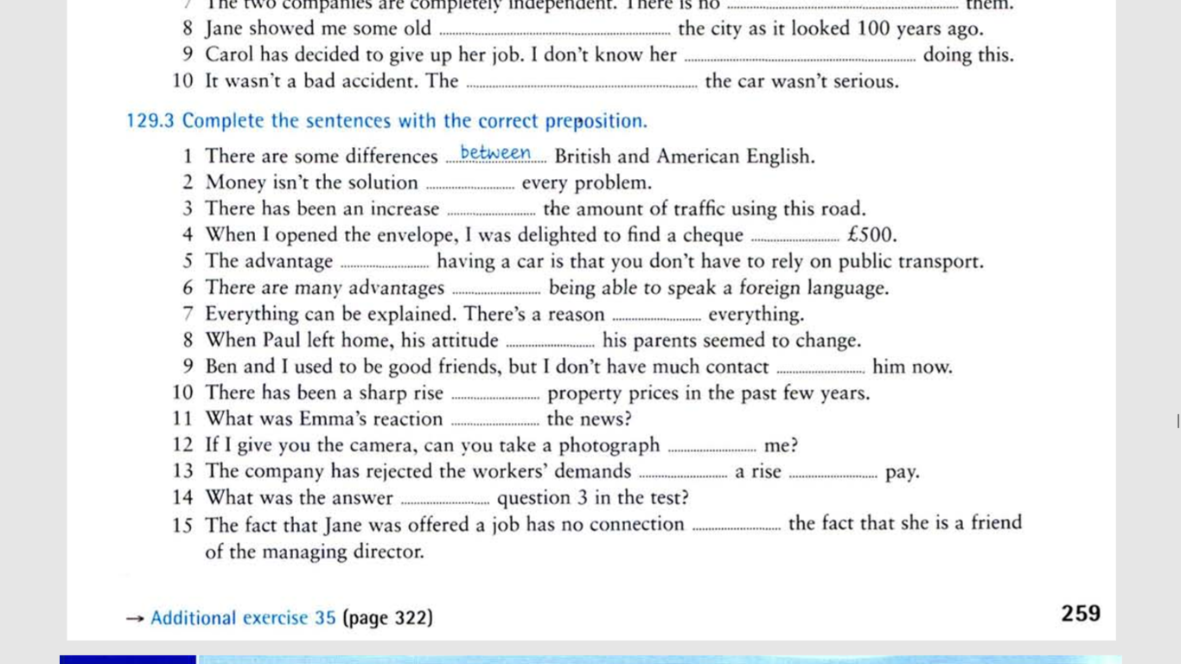

ANSWERS
Task 1
1. He gave her a check _____ a lot of money.
for
in
of
to
with
2. The reason _____ this meeting is to discuss the merger.
for
in
of
to
with
3. The decrease _____ profits is due to the bad market.
for
in
of
to
with
4. There is a real demand ______ new products.
for
in
of
to
with
5. We have seen a fall ______ prices recently.
for
in
of
to
with
6. The cause ______ his problems is his family.
for
in
of
to
with
7. Did you do any damage ______ the house?
for
in
of
to
with
8. I think your attitude _____ your sister is very bad indeed.
for
in
of
to
towards
9. The difference _____ the two is very slight.
for
in
between
to
with
10. He took a photograph ______ his girlfriend.
for
in
of
to
with
11. Do you have a good relationship ______ most of your relatives?
for
in
of
to
with
12. She wasn't aware ______ his reaction to the problem.
for
in
of
to
with
13. Did you send Alice an invitation ______ the party?
for
in
of
to
with
14. The connection _______ the two victims was minimal.
for
in
of
to
between
15. The advantage ______ having free time is that you can do anything you want with it.
for
in
of
to
with
16. He made a mistake _______ thinking that Alice was someone he could easily fool.
for
in
of
to
with
Task 2
1. We had little hope of success; nonetheless, we decided to perform the operation.
2. The cash-for-vote scandal did a lot of harm to his reputation as a conscientious politician.
3. We have to find a substitute for it.
4. We should deem it as an attack on our right to privacy.
5. In many cities the cost of living is pretty high.
6. We would like to see a big increase in productivity.
7. I have no interest in politics.
8. I have no faith in her capabilities.
9. I have heard that the government is planning to raise the tax on automobiles.
10. I admire their way of doing things.
Task 3
1. I really need a BREAK ___ drinking alcohol!
of
from
at
2. Her skin has a really bad REACTION __ the sun.
with
to
at
3. There has been a huge RISE ___ food prices recently.
at
with
in
4. I think I have an ADDICTION ___ chocolate.
with
to
about
5. I have huge RESPECT ___ my teachers at school, now I know how hard it can be!
with
in
for
6. I went on a date on Tuesday and I felt a real CONNECTION ___ him.
with
at
about
7. I had no CONTROL ___ the England team losing that game!
over
for
about
8. There was a huge SEARCH ___ my missing camera, but nobody found it.
with
for
at
9. She caused huge DAMAGE ___ his car when she crashed into it.
about
for
to
10. I didn't think there was any REASON ___ him to shout at me.
for
to
between
Task 4
