L37 – Thanksgiving day – Listening
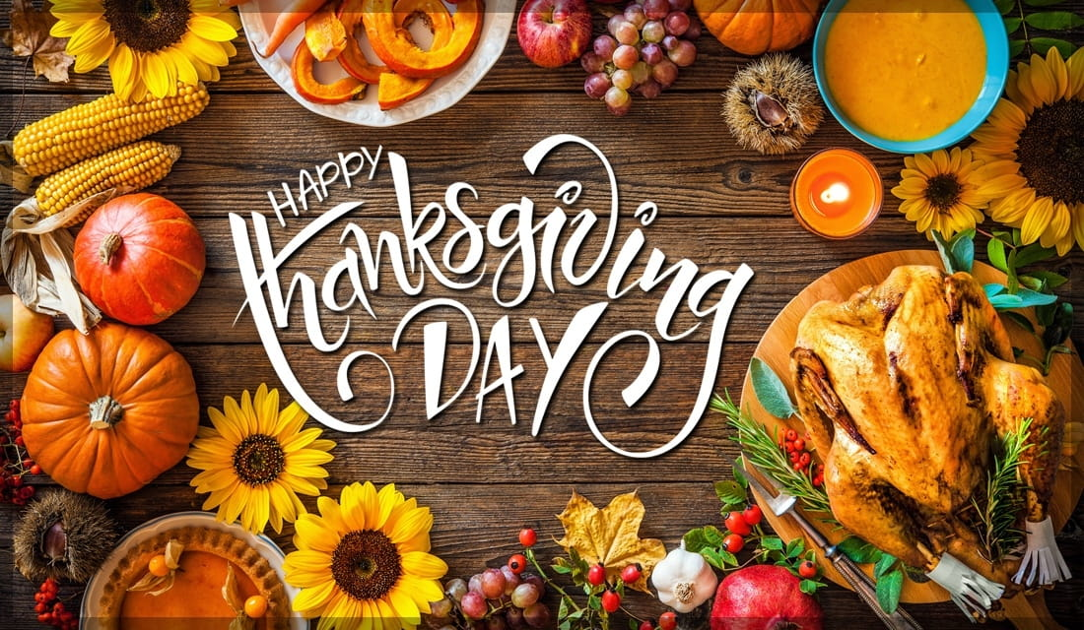
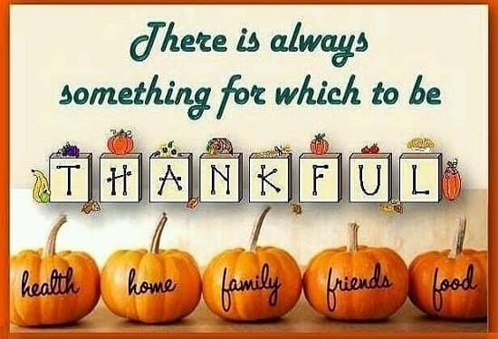

Audio 1.
Assignment 1.
Thanksgiving is a very American holiday. It is also (1) ____ Thanksgiving Day. It is celebrated on the fourth Thursday in November every year. It used to be a (2) ____ holiday to give thanks to God. There are two versions of the origins of this holiday. One is thanks for the early (3) ____ arriving in America safely. On December the 4th, 1619, a group of English pioneers arrived at a place called Berkeley Hundred, in Virginia. The group made a promise that the day of their (4) ____ should be a "day of thanksgiving" to God. The second version is the thanks given to Native Americans for teaching the pilgrims how to (5) ____ eels and grow corn in Plymouth, Massachusetts. In 1941, President Roosevelt (6) ____ Thanksgiving a federal holiday.
The (7) ____ event of any Thanksgiving is the Thanksgiving dinner. It is traditional to have baked or roasted turkey. This is usually accompanied with mashed potatoes, sweet potatoes, (8) ____ vegetables, cranberry sauce, and gravy. Pumpkin pie is the most commonly (9) ____ dessert. The Thanksgiving holiday weekend is one of the busiest times of the year for traveling. It is a four-day or five-day weekend vacation for most schools and colleges, and (10) ____ businesses and government workers get three or four days off. Thanksgiving is also the unofficial signal for Christmas preparations to (11) ____. Once Thanksgiving finishes, stores fill their (12) ____ with Christmas goods. It is also a bad time to be a turkey.
Put the correct words from this table into the article.
1. | (a) | called | (b) | calling | (c) | calls | (d) | call
2. | (a) | religion | (b) | religious | (c) | religiously | (d) | religions
3. | (a) | settlers | (b) | settles | (c) | settled | (d) | settlement
4. | (a) | arrives | (b) | arrived | (c) | arrival | (d) | arrival
5. | (a) | caught | (b) | catches | (c) | catch | (d) | catching
6. | (a) | took | (b) | made | (c) | did | (d) | had
7. | (a) | main | (b) | mainly | (c) | mainline | (d) | mains
8. | (a) | fell | (b) | falling | (c) | fall | (d) | fallen
9. | (a) | eating | (b) | eats | (c) | ate | (d) | eaten
10. | (a) | most | (b) | many | (c) | much | (d) | more
11. | (a) | beginning | (b) | begins | (c) | begin | (d) | began
12. | (a) | elves | (b) | delves | (c) | halves | (d) | shelves

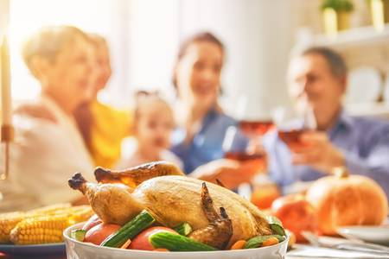

Assignment 2.Watch the video and answer the following questions.
https://www.youtube.com/watch?v=-BQSOkkoDjc
1) What did the Pilgrims want?
- They wanted to go to America.
- They wanted to reform and purify England's churches.
- They wanted to have their own religious holiday.
- They wanted to build their own churches.
2) Where did the Pilgrims go first?
a. the Netherlands
b. America
c. Denmark
d. France
3) Who did they persuade to finance their journey to the New World?
a. monarch
b. catholic church
c. London stock company
4) How was called Pilgrims` ship?
a. Bellflower
b. Mayflower
c. Sunflower
5) When the Pilgrims sailed?
a. in September 1620
b. in October 1625
c. in July 1619
6) How many passengers were on the journey to America?
- 100
- 107
- 102
7) Why did the Pilgrims choose Plymouth Rock to settle?
a. because of brook full of fish
b. because of plentiful land
c. because of friendly indigenous population
8) Did the Native Americans attack the colonists?
- No, they didn't.
- Yes, they did.
9) What was the name of the man who made contact with the Pilgrims?
10) What was the name of the indigenous person who helped them very much?
11) How did the governor react to the drought?
- He ordered to steal water from the natives.
- He thought about digging more wells.
- He ordered a day of fasting and prayer.
- He thought about returning to Europe.
12) When is the current Thanksgiving Day held?
- On the first Monday of November.
- On November 23.
- On the fourth Thursday of November.
- On November 29.
13) What do Americans NOT eat on Thanksgiving Day?
- turkey
- stuffing
- mashed potatoes with gravy
- sweet potatoes
- cranberry sauce
- sweet corn
- pumpkin pie
- soul cakes

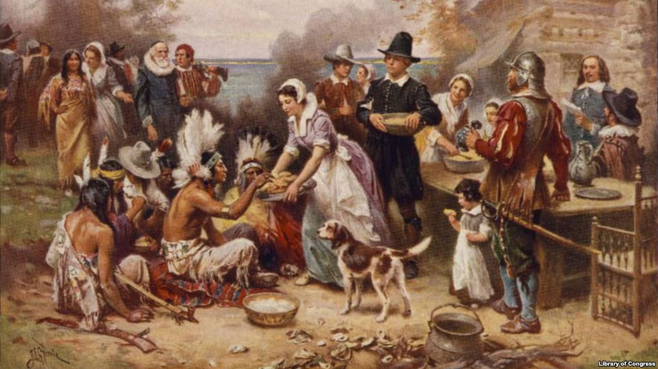

Assignment 3. Watch the video and answer the following questions.
https://www.youtube.com/watch?v=i5YckMkwmm4

1) What were Rachel and Monica making for dessert?

2) Where Ross and Joe wanted to go?

3) Who is Janine?

4) Who came to visit?

5) What's the weird thing Rachel put in her trifle dessert?

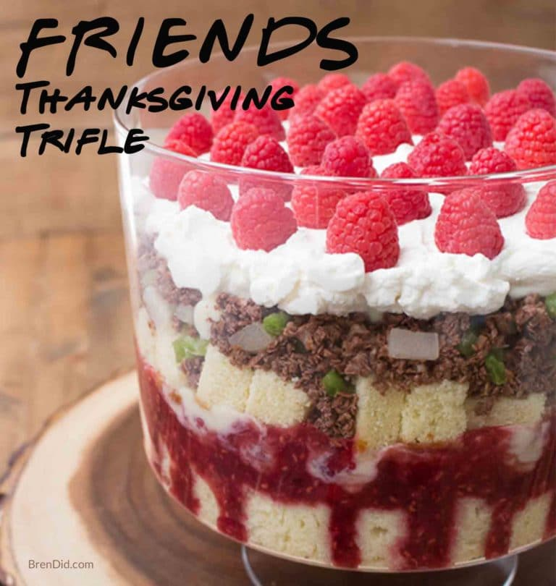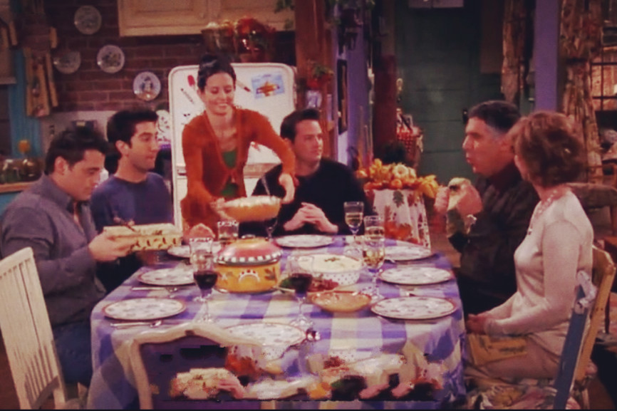

KEYS
1.
1. | (a) | called | (b) | calling | (c) | calls | (d) | call
2. | (a) | religion | (b) | religious | (c) | religiously | (d) | religions
3. | (a) | settlers | (b) | settles | (c) | settled | (d) | settlement
4. | (a) | arrives | (b) | arrived | (c) | arrival | (d) | arrival
5. | (a) | caught | (b) | catches | (c) | catch | (d) | catching
6. | (a) | took | (b) | made | (c) | did | (d) | had
7. | (a) | main | (b) | mainly | (c) | mainline | (d) | mains
8. | (a) | fell | (b) | falling | (c) | fall | (d) | fallen
9. | (a) | eating | (b) | eats | (c) | ate | (d) | eaten
10. | (a) | most | (b) | many | (c) | much | (d) | more
11. | (a) | beginning | (b) | begins | (c) | begin | (d) | began
12. | (a) | elves | (b) | delves | (c) | halves | (d) | shelves

2. 1) What did the Pilgrims want?
  - They wanted to go to America.
  - They wanted to reform and purify England's churches.
  - They wanted to have their own religious holiday.
  - They wanted to build their own churches.
2) Where did the Pilgrims go first?
a. the Netherlands
b. America
c. Denmark
d. France
3) Who did they persuade to finance their journey to the New World?
a. monarch
b. catholic church
c. London stock company
4) How was called Pilgrims` ship?
a. Bellflower
b. Mayflower
c. Sunflower
5) When the Pilgrims sailed?
a. in September 1620
b. in October 1625
c. in July 1619
6) How many passengers were on the journey to America?
  - 100
  - 107
  - 102
7) Why did the Pilgrims choose Plymouth Rock to settle?
a. because of brook full of fish
b. because of plentiful land
c. because of friendly indigenous population
8) Did the Native Americans attack the colonists?
- No, they didn't.
- Yes, they did.
9) What was the name of the man who made contact with the Pilgrims?
He was called Samoset.
10) What was the name of the indigenous person who helped them very much?
His name was Squanto.
11) How did the governor react to the drought?
- He ordered to steal water from the natives.
- He thought about digging more wells.
- He ordered a day of fasting and prayer.
- He thought about returning to Europe.
12) When is the current Thanksgiving Day held?
  - On the first Monday of November.
- On November 23.
- On the fourth Thursday of November.
- On November 29.
13) What do Americans NOT eat on Thanksgiving Day?
- turkey
- stuffing
- mashed potatoes with gravy
- sweet potatoes
- cranberry sauce
- sweet corn
- pumpkin pie
- soul cakes

