084_intermediate_grammar
Passive Voice

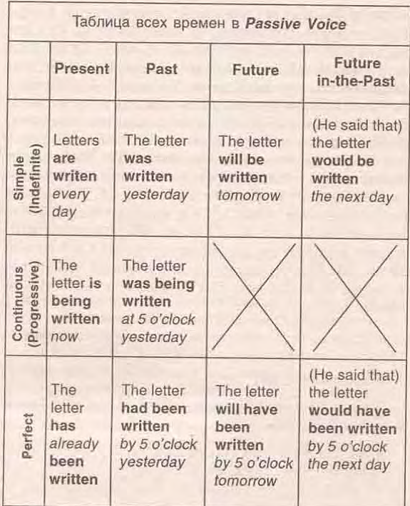

Exercise 1
Transform the following sentences into Passive
1. He stole a lot of money from the shop.
2. By six o'clock they had finished the work.
3. At twelve o'clock the workers were loading the trucks.
4. By three o'clock the workers had loaded the trucks.
5. We send our daughter to rest in the south every year.
6. They will show this film on TV.
7. They are building a new concert hall in our street.
8. She bought potatoes yesterday.
9. We will bring the books tomorrow.
10. They are repairing the clock now.

Exercise 2
Transform the following sentences into Passive
1. They sell milk in this shop.
2. I have translated the whole text.
3. They broke the window last week.
4. When I came home, they had eaten the sweets.
5. We will do the work in the evening.
6. He wrote this book in the 19th century.
7. They were playing tennis from four till five.
8. They have made a number of important experiments in this laboratory.
9. Livingstone explored Central Africa in the 19th century.
10. By the middle of fall we had planted all the trees.
Exercise 3
Put the words in the correct order
1. Have all these books been read?
2. Whom were these letters written by?
3. The letter has just been typed.
4. Sue showed me the picture which had been painted by her husband.
5. I will not be allowed to go there.
6. He has been told everything, so he knows what to do now.
7. All the questions must be answered.
8. The door has been left open.
Exercise 4
Fill in the gaps.
1. Two reports on Hemingway's stories in our group last month. Both of them were very interesting.
2. He said that Grandmother's letter the day before.
3. Two new engineers just to the head of the department.
4. Don't worry, everything will be all right: the children to the theatre by the teacher and they back to school in the evening.
5. I am sure I at the lesson tomorrow.
6. They told me that the new student much about.
7. The hostess said that one more guest .
8. The newspaper said that an interesting exhibition in the Hermitage the next week.
9. This new dictionary everywhere now.
10. All the texts through yesterday and not a single mistake .

Exercise 5
Choose the correct answer
- Yesterday we ... to the party by our friends.
are invited
were invited
invite
- Our house ... now.
is being repaired
is been repaired
has being repaired
- The message ... by e-mail tomorrow by 10 oclock.
will be sent
will have been sent
will be sended
- Nick ... to be a very interesting person.
has been known
is known
is been known
- Our school conferences ... once a year.
were held
are being held
are held
- Your results ... and found correct.
have been studied
has being stidied
were studied
- This book ... by October 15.
would been published
will have been published
will been published
- He ... in a small Ukrainian village not far from the sea.
was born
am born
has been born
- All the participants of the conference ... about the time-table.
should have been told
should be told
should been told
- All tasty things ... at once. There is nothing on the plates.
have been eaten
has being eaten
were eaten
- My suitcase ... when my friends came to see me off.
was already being packed
had already been packed
was packed
- The text ... translated.
was already
is already
has already been

